Precious Corals Online Course Script
Table of Contents
1. Introduction 5
2. History and Tradition 7
2.1. Cultural Heritage 13
2.2. Some noteworthy artefacts 22
2.2.1. Coral Reliquary of the Saint Queen of Portugal 22
2.2.2. Figure of musician from the "Mountain of coral" 23
2.2.3. Casket with writing set 24
2.2.4. Large Salt Shaker 25
2.2.5. Holy Water Vessel with Saint John the Baptist 26
2.2.6. Napoleon's I Ceremonial Sword 27
2.3. Corals as Plants? 30
2.4. Corals as Gem Materials (CIBJO Nomenclature) 30
2.4.1. What is CIBJO? 31
2.4.2. CIBJO Blue Books 32
2.4.3. CIBJO Terms and Definitions for corals 33
2.4.4. Biogenic versus organic gem materials 35
3. Simplified Biology of Precious Corals 37
3.1. Taxonomy of Corals 38
* precious corals in red, common corals in grey 40
3.2. Precious Coral versus Reef Coral 42
3.3. Common corals 43
4. Precious Coral Varieties 44
4.1. Aka, Moro or Oxblood 45
4.2. Momo, Cerasuolo or Satsuma 45
4.3. Angel Skin, Boké or Magai 45
4.4. Pure White or Shiro 46
4.5. Midway, Rosato or White/Pink 46
4.6. Deep Sea or Shinkai 46
4.7. Garnet 47
4.8. Misu, Missu or Miss 47
4.9. Sardinian or Mediterranean 47
4.10. Sciacca 48
4.11. Dead coral 48
5. Common Coral Varieties 49
5.1. Bamboo coral 49
5.2. Black coral 49
5.3. Golden Coral 50
5.4. Blue coral 50
5.5. Sponge coral 50
5.6. Lace corals 50
6. Coral Processing and Fashioning 52
7. Value Factors 54
7.1. Colour 54
7.2. Colour distribution 54
7.3. Lustre 55
7.4. Surface quality 55
7.5. Size 55
7.6. Symmetry 55
8. Treatments and Disclosure 57
8.1. General Disclosure Protocols 58
8.1.1. Disclosure requirements for treated coral requiring general information 58
8.2. Specific Disclosure Protocols 59
8.2.1. Disclosure requirements for treated coral requiring specific information on treatments 59
9. Identification of Precious Coral 61
9.1. Gemmological Properties 63
9.2. Advanced Identification Techniques 65
9.2.1. Infrared Spectroscopy 65
9.2.2. Raman Spectroscopy and PL Spectroscopy 65
9.2.3. Carbon-14 Dating 66
9.2.4. DNA Fingerprinting 66
10. Coral Imitations 68
11. Caring for Coral 70
11.1. Normal care 70
11.2. Special care 70
11.3. Special recommendations for window display 71
12. CITES 73
12.1. CITES Appendixes 73
12.1.1. Appendix I 73
12.1.2. Appendix II 74
12.1.3. Appendix III 74
12.2. CITES and Corals 74
13. Sustainability 78
13.1. Fishing regulations 79
13.1.1. Taiwan 79
13.1.2. Japan 79
13.1.3. Mediterranean (EU) 80
13.2. Sustainable Coral Projects 81
13.2.1. Precious coral repopulation in Japan 81
13.2.2. Sardinian Scuba Divers’ Initiative 82
13.2.3. Red Coral Research in Monaco 82
13.2.4. CIBJO Initiatives 82
14. Conclusion 84

Introduction
Precious corals are amongst the oldest gem materials used for adornment and have been in-use since the Neolithic (ca. 8000 BC). This is also true for other biogenic gem materials, sometimes referred to as “organic gems”, e.g., shell, mother-of-pearl and pearls.
Precious coral corresponds to the bio-mineralised exoskeleton of a very limited number of marine species of the phylum Cnidaria that thrive in the eastern Atlantic Ocean, Mediterranean Sea and off the coast of Japan, Taiwan, Vietnam, Hawaii and in Pacific Ocean (e.g. Midway). Tradition and cultural heritage are strongly associated with the coral industry in these parts of the world and elsewhere where corals have been cherished e.g. Mongolia, Tibet, India, Yemen, North Africa, Benin.
At the trade level, the different varieties of precious coral show different colour ranges and quality factors, it is important not only to distinguish between those varieties but also to recognise those factors in each variety. Moreover, it is also important to know what treatments are currently being used to enhance the visual characteristics, durability and stability of corals since treatments must be disclosed along the supply chain and to the end consumer. Precious corals do have a few imitations on the market, and it is important to list those that may occur and their identification features.
The challenges for issuing a gemmological report on precious corals are many and some laboratories do not have the facilities or the expertise required to differentiate between the different species; such information being important in terms of the import/export regulations that might apply in different jurisdictions (see - the Convention on International Trade in Endangered Species of Wild Fauna and Flora) where a few precious coral species are currently monitored under Appendix III. Understanding CITES and the significance of the Appendices is key to fully comprehending the current precious coral trade.
Sustainability concerns pushed by climate change have put the issue of corals in general on the agenda of CIBJO, The World Jewellery Confederation, where a Coral Commission was introduced in 2015 to address these matters. The main goals of this commission are to clearly separate precious corals from reef corals, to establish clear disclosure procedures for treated coral and to promote a transparent trade nomenclature.

History and Tradition
Key concepts
Coral is used as adornment since the Iron Age
Corallium rubrum from the Mediterranean has been exported to Asia since at least the 1st Century AD
Pagan and religious beliefs on the protective powers of corals come from Greek mythology
Corals are present in sacred texts and traditions in many religions: Christian, Muslim, Jewish, Buddhist, Hindu

The use of coral as a precious adornment dates back to the Iron Age as many biogenic gem materials do. The only significant historical source for precious corals is the Mediterranean Sea it is therefore interesting to see that coral is found in very old artefacts in lands that are distant from the historic Mediterranean sources.
Theophrastus (372-287 BC), the Greek naturalist and the Roman naturalist Pliny, the Elder (23-79 AD) already mention Mediterranean coral trade to the Orient. Pliny’s quote in his famous Natural History in the first century AD, is supported by the most reliable ancient treatise, the Periplus Maris Erythraei from the 1st century AD, in which coral is mentioned as one of the precious goods exported to India. The appreciation of coral by the Indian populations has never failed, so much so that in the last two centuries the importation of Corallium rubrum from the Mediterranean Sea has increased to produce jewels and amulets like the Navaratna, the most effective talisman of nine gems where the coral has an important protective role.

 | 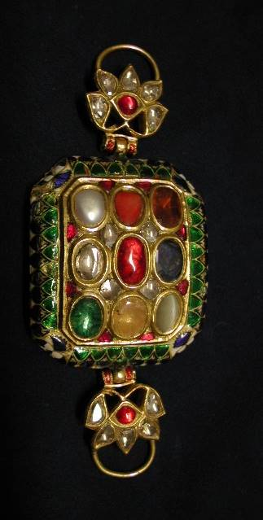 | 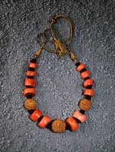
Figure 1:
Coral Indian necklace from I century AD. © www.lucianopedicini.it
Indian Navaratna precious gold arm band, effective talisman of nine gems where the coral has an important protective role © CristinaDelMare
Traditional Indian coral necklace © www.lucianopedicini.it

Tibet and Central Asian countries are other examples of remote regions where coral was, and still is, very much appreciated. In Buddhist cultures, coral not only denotes personal wealth, but also takes on a symbolic meaning linked to its vital colour and an important propitiatory function for health and well-being.

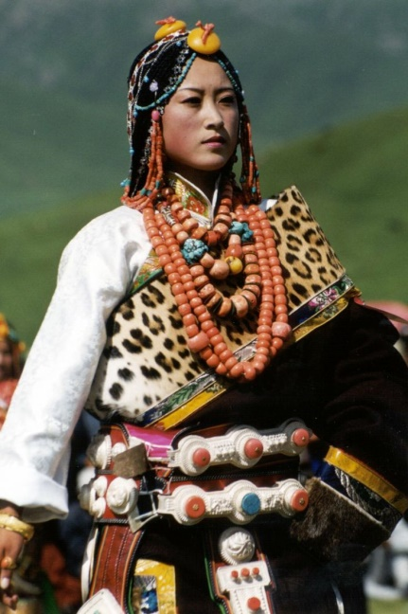 | 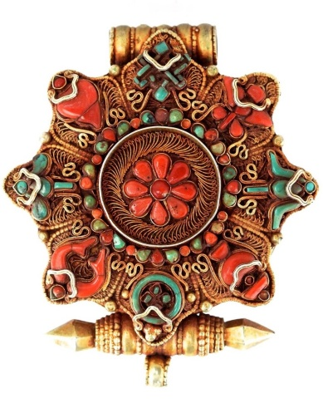
Figure 2: Woman with traditional coral ornaments from Qinghai Cina ©CristinaDel Mare
Amulet pendant Gau. Gold, coral, turquoise. Tibet © CristinaDelMare
Woman from Quingai Cina with coral ornament © PatriziadeMarco

In more recent times the African kingdom of Benin, in today’s Nigeria, traded with the Portuguese as far back as the 16th century, valued coral more than anything else. Even today, Benin royalty still wears coral strung vests in formal ceremonies.

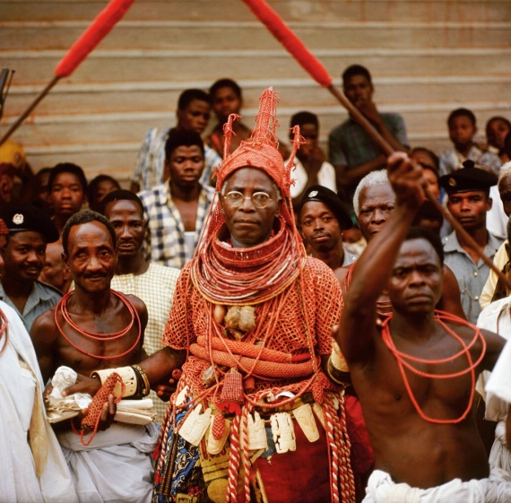 | 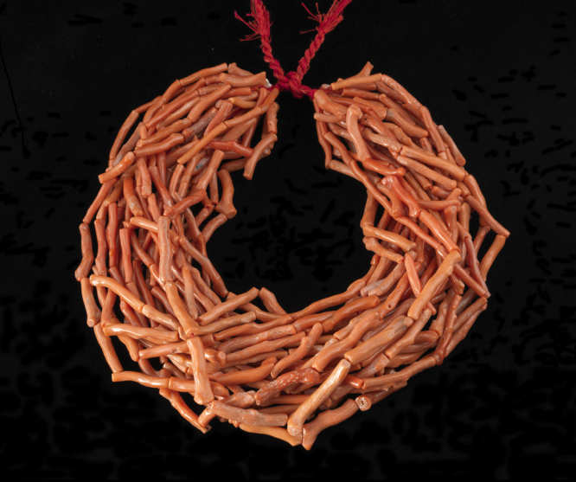
Figure 3: Oba Akenzua II, King of Benin, with traditional ceremonial coral costume,1975 © www.bridgman.it
Necklace made of "maometti" coral beads. Manufactured in Naples destined for African market. Last quarter of 19th century. Antonino De Simone collection © LucianoPedicini

Interestingly, corals are cited in the sacred document translations of the Tanakh and Bible (Job 28:18), in Quran descriptions of Paradise (LV 22-23,58) and in mythology, especially in Metamorphoses, the work by Ovid (Publius Ovidius Naso 43 BC-17 AD). In this text it is said that Perseus decapitates Medusa, whose gaze turns her enemies to stone, to set Andromeda free. Perseus then buries her head in the sand, covering it with leaves and branches which hardened and were taken into the sea by nymphs and transformed into coral. Here lies the origin of the belief in coral’s powers against poison, the evil eye, infertility and epilepsy. The ancient myths on the coral stem from magical symbolism linked to its metamorphic nature poised between the three kingdoms: not mineral even if petrified, not planted even if branched, not animal even if blood-coloured. In fact, the true biological nature of the coral was not revealed until the 18th century.
This pagan tradition was recouped, especially during the middle Ages, and in the Renaissance in Christian devotion, for being a symbol of Christ' saving blood capable to redeeming all evils. Even today many of those beliefs are still culturally impregnated in many communities and cultures.
As an allegory of the Saviour, coral has been used in masterpieces of sacred art that unify the splendour of the golden metal matched with the passionate red of the coral. There are many examples of the use of precious coral in Catholic devotional context and one of the most interesting is the unusual 14th century reliquary of the True Cross at the Machado de Castro National Museum, Coimbra, Portugal. Other masterpieces were produced in Sicily, especially in Trapani, during Baroque period as for example ostensory, chalices, holy water stoups, tabernacles or altar decorations, today kept in many Italian churches.

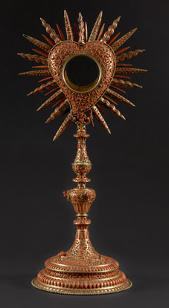 |  | 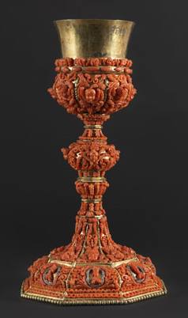
Figure 4: Heart shape monstrance, gilded copper, coral. Craftsmen in Trapani, first half of 18th century. Galleria Regionale della Sicilia collection © LucianoPedicini
Chalice, gilded copper, coral. Craftsmen in Trapani, first half of 18th century . Museo Liverino collection © LucianoPedicini

The more interesting testimonies are however in paintings. Renaissance and pre-renaissance iconographic representations of children, Baby Jesus in particular, were commonly made wearing a small branch of coral or a tiny coral rosary. One of the most famous examples is the Madonna della Vittoria by Andrea Montegna (1496) that resides in the Louvre Museum, Paris, or Madonna di Sinigallia by Piero della Francesca (1480).
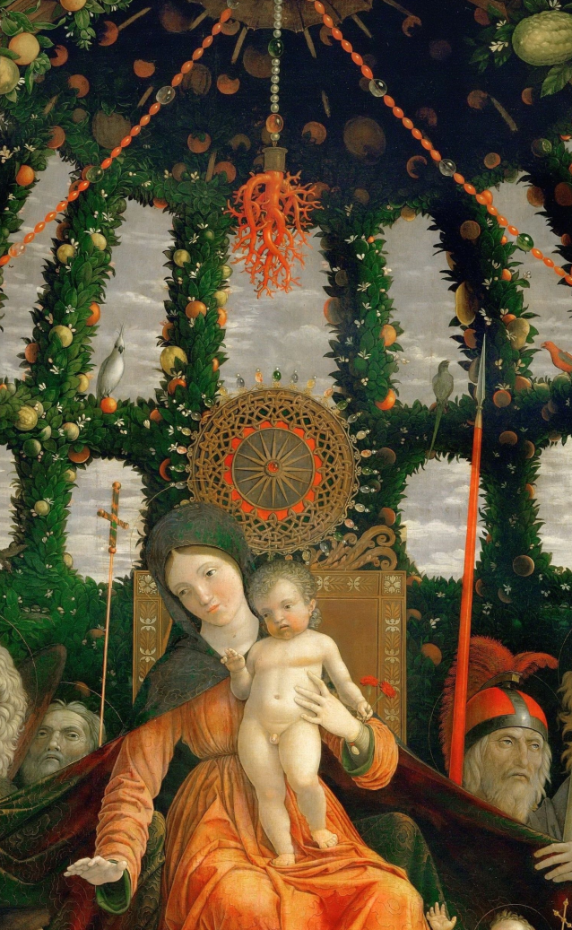 | 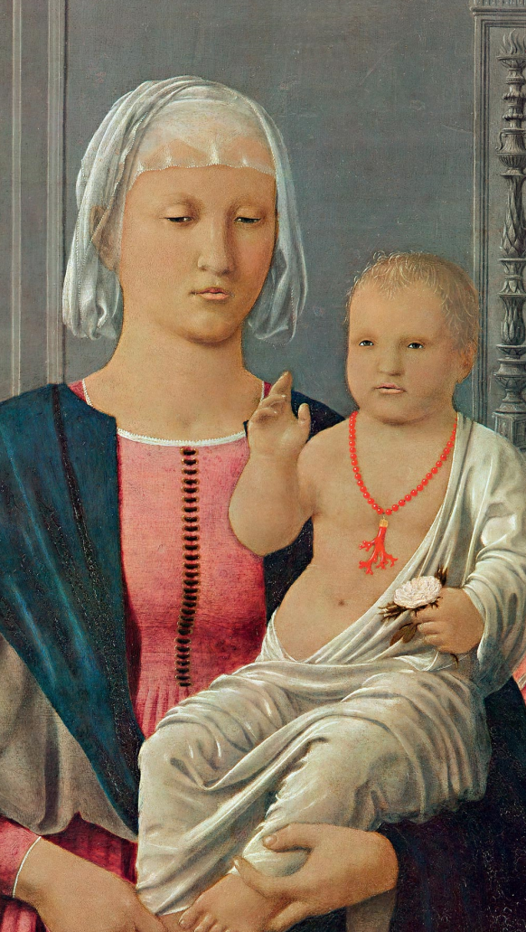
Figure 5: Andrea Montegna Madonna della Vittoria 1496, Musèe du Louvre, Paris
Piero della Francesca, Madonna di Senigallia, 1470-1485, Galleria Nazionale delle Marche, Italy

In Christian devotional artefacts the use of coral was, therefore, abundant. Since the 15th century coral beads were used to make Christian rosaries, encouraging the spread of coral to several North Europe countries. Even in Muslim, Hindu and Buddhist communities, coral beads were used to make their rosaries, ma'ashbah or malas.
The so-called pointers, or yad, usually made of silver that are used by the reader to follow the sacred text of the Torah in Judaic tradition, have been also embellished with precious coral.

 | 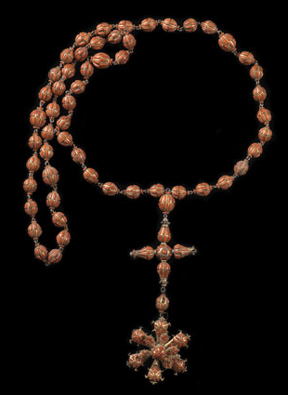 | 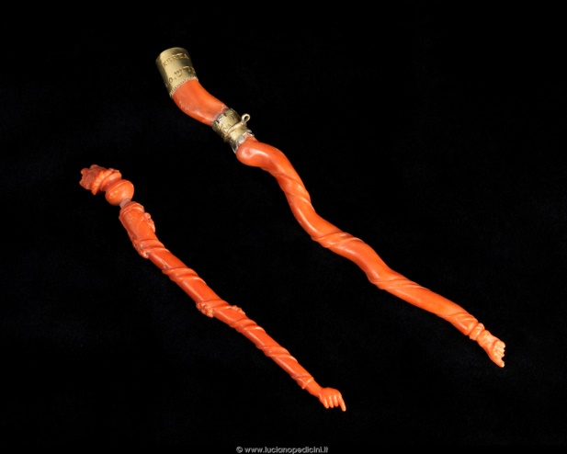
Figure 6: Cleves van Joos, Lady with coral rosary, Early XVI century, Museo degli Uffizi, Florence
Rosary coral beads , Mid 17th century. Museo Regionale Pepoli, Trapani ©LucianoPedicini
Yad pointers of sefer, coral and silver. Manufacture in Leghorn 1801, Museo Comunità ebraica Martini ©LucianoPedicini

Cultural Heritage
Key concepts
Corals are deeply rooted in the local culture of traditional manufacturing areas like Torre del Greco in Italy and Kochi in Japan
The discovery of the Sciacca dead coral deposits made huge negative impact on the price of corals in the late 19th century
Precious coral production in Japan began in 1871
Precious coral production in Taiwan started in 1923

The beginning of the systematic coral harvesting in the Mediterranean can only be established around the first millennium BC. There are signs of precious coral fragments encrusted in the wooden structure of a Sixth century BC Greek boat, discovered near Marseille in 1993. Near the islands off the coast of Marseille lead elements and stone were also found and they resemble gears used for coral harvesting. The coral fishing method adopted by the Greeks, and later by the Romans, seems to have employed similar systems used for ordinary fishing.

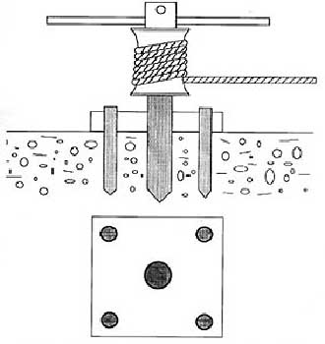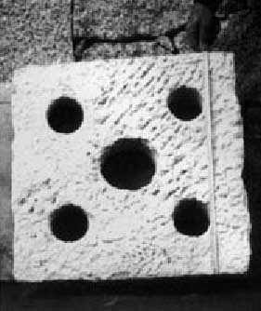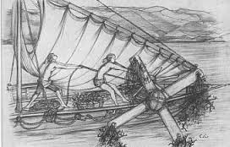
Perforated stone resemble gears used for coral harvesting discovered near Marseille.
Figure XX: Archaic winch for coral fishing

In Medieval times we already have evidences of Mediterranean coral fishing through interesting correspondence found in the Genizah of the Cairo Synagogue dated XII-XIV centuries. Drafted in Judeo – Arabic (Arabic language written in Jewish characters) these letters tell us about the intense coral trade between the Sicilian Jews and the Jewish communities settled in Alexandria and Cairo, from where they sent large amounts of coral to India. However, Jewish communities were dedicated only to the polish and trading coral, leaving coral fishing to the Christian and Muslim communities.

Figure XX: Commercial letter from Cairo Genizah, mentioned coral trades from Sicilian Jews to Jewish communities settled in Alexandria and Cairo. © University Library Cambridge. Taylor Schechter Collection, Ts 20,76

A particular coral fishing technique, that has remained unchanged with minor variations for centuries, until the end of 1900, can be traced back to the Arab community that lived in the area. This coral harvesting technique employs a tool called ingegno (because it was an ingenious idea by the Arabs), consisting of a wooden cross that had several nets hooked at each of the four ends, of variable length between 6 and 9 meters.
The ingegno was placed on the boat's deck and dropped into the sea. Once the fishing apparatus sunk, it starts flowing, remaining at 2-3 meters from the sea bottom, while the wide-mesh nets, called rictze or rezzinielli by the Neapolitan fishermen, flying on the coral reefs, captured only the thicker coral branches, doing a selective and careful fishery. The success of the fishing operation was mainly based on good knowledge and ability of the boat's chief, to avoid the risk of losing the nets as well as the harvested corals.

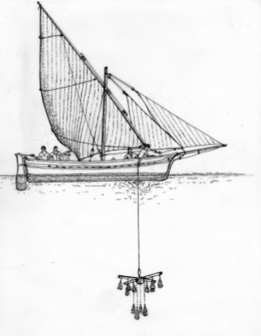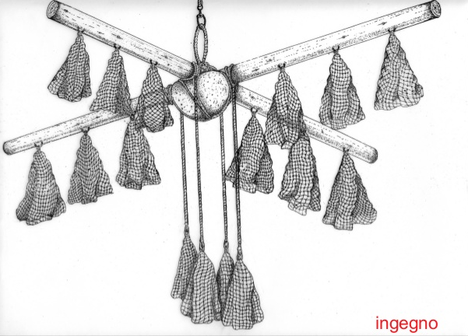
Ancient coral harvesting technique employs a tool called "ingegno" © Associazione Tutela Tradizioni Popolari Trapanesi

Up to the late Middle Ages, Muslims intensively fished coral in the Western Mediterranean and along the North Africa coasts, in Ceuta (Morocco), Bona (Spain), Mersa el Kharez (Algeria) and Tabarka (Tunisia), competing with maritime European trading powers of Genoa, Venice, Pisa as well as with the Catalan, Provencal and Aragonese merchant boats to expand coral supply.
In the 16th century, coral trade was concentrated between Genoa and Leghorn, two important gathering points, processing and selling Mediterranean red coral. The leading position of the Genoese did not last long. In 1561, two men from Marseille founded in Bona, Algeria, the first French base for coral fishing, dubbed the “French Bastion” which remained active, with ups and downs, for more than a century. In its main objectives, there was the elimination of the Genoese colony of Tabarka in Tunisia, where Genoa continued to profit from coral fishing in considerable quantities. The French exclusive privilege of coral fishing in Tunisian waters culminated in 1741 with the establishment at La Calle of the "Royal Africa Company" (Compagnie Royale d'Afrique) with headquarters in Marseille. From that time on, Marseille became a flourishing port of commerce and of coral processing.

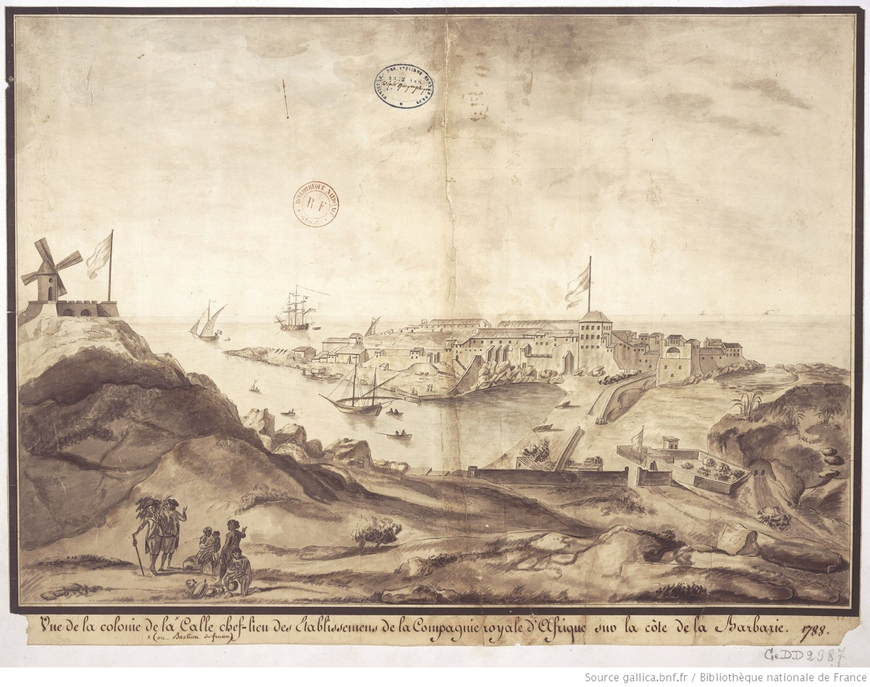
Figure XX: View of La Calle chief town colony of Royal Society of Africa establishments on the coast of Barbary, 1788. © Bibliothéque National de France

The eighteenth century was one of the periods of greatest demand for coral. In 1717, the Dey (ruler) of Algiers sent to the Sultan of Constantinople, among other regalia, 75 rosaries decorated with coral. In the 1700’s it was customary to give coral rosaries to Muslim rulers along with long guns and pistols, encrusted with coral. The practice was extended to the gifts sent to Christian sovereigns. Guns and harquebuses produced in Algeria and Morocco, decorated in silver, coral and mother-of-pearl, were given to the king of Naples and became part of the Royal Secret Armory, now housed in the National Museum of Capodimonte, Naples. These precious gifts were a vehicle of styles and decorative elements that certainly influenced the artistic taste of the countries in contact with them.
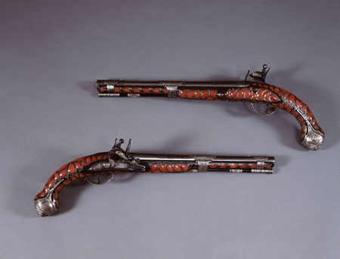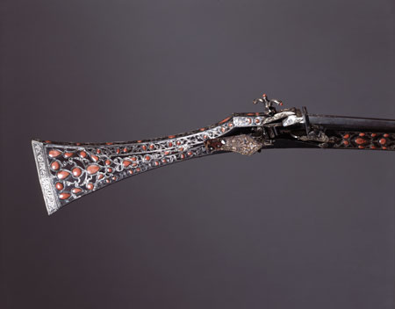
Figure XX: Pair of pistols of Algerian manufacture, late 18th century. Bourbon Armory – National Museum of Capodimonte © LucianoPedicini
Detail of harquebus with silver and coral decorations of Algerian manufacture, late 18th century. Bourbon Armory – National Museum of Capodimonte © LucianoPedicini

In the early 1700’s, Ferdinando Marsili in his treatise Histoire Physique de la Mer still mentions coral fishing boats using "ingegno". Throughout the 18th century, Mediterranean coral harvesting had its greatest development. It was also the period in which the flotillas of Torre del Greco intensified coral fishing.

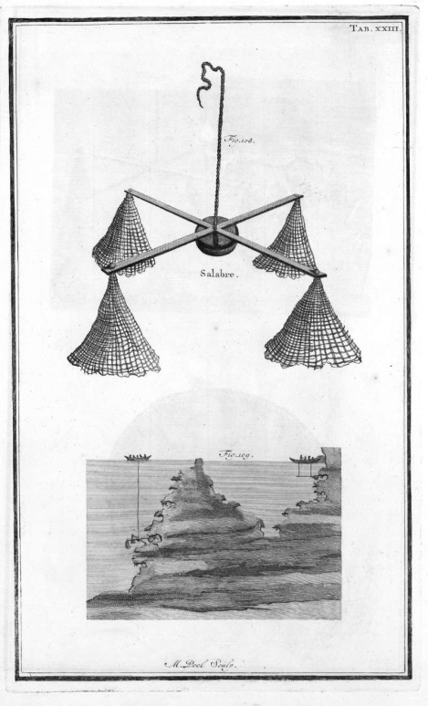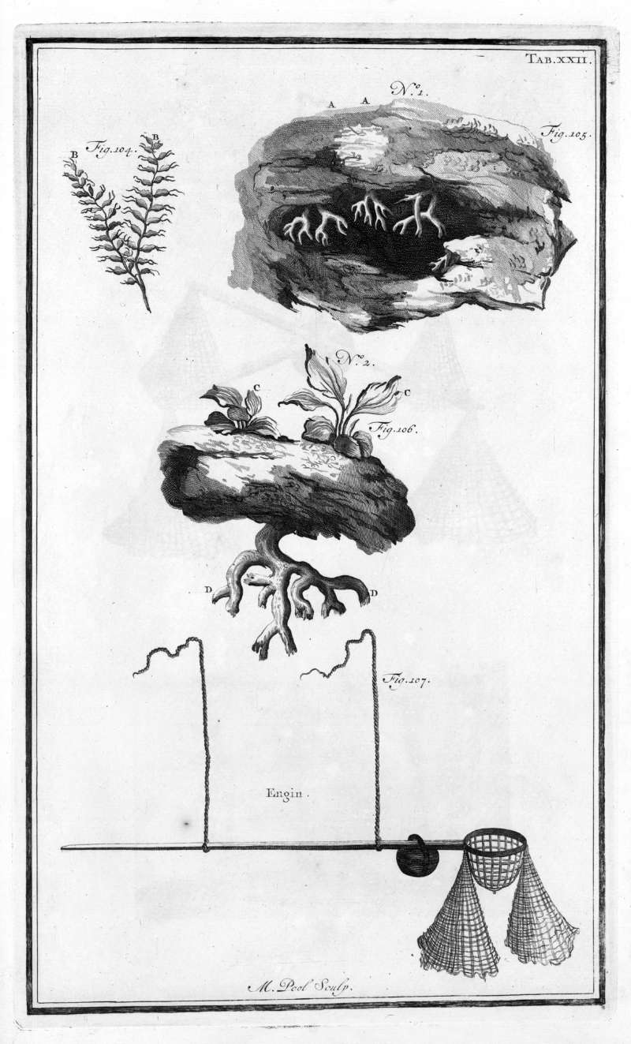
Figure XX : Ferdinando Marsili’s "Histoire physique de la Mer" (1710) tables 23 and 24 concerning the coral fishing with "ingegno".

Until the end of the eighteenth century, raw coral harvested by Torre del Greco fishermen was mainly sent to Leghorn, from where, after being worked, it was exported to Western and Eastern markets. In order to respond the commercial monopoly of Leghorn, it emerges the idea of systematically working raw coral at Torre del Greco.
In the late 18th century, the kingdom of Naples established the Reale Compagnia del Corallo in Torre del Greco, Italy, following a long-time tradition in coral manufacture in that fishing village in the Gulf of Naples, in the vicinity of the famous Vesuvius volcano, with reported activity as early as the 15th century. A code was then introduced, to regulate coral harvesting.
Paul Barthelemy Martin, a Genoese born merchant, had his own workshop of coral processing in Marseilles. In 1805 following the strong decline of coral processing caused by the French revolution, he landed in Naples where he obtained a ten-year privy from King Ferdinand III of Bourbon to start a factory for coral processing, using coral fished by Neapolitans, with the obligation to instruct some young people of the town. So it was that Torre del Greco linked to his name not only the coral fishing, but also its processing. The “Reale Scuola di Incisione e Lavorazione del Corallo” was established in Torre del Greco with visiting professors coming from the art world and from other coral manufacturing centres (e.g. Marseille, Genova and Trapani) to train the local coral artisans with more refined technical and artistic skills.

Between 1875 and 1880, extensive coral beds were discovered about three miles off the coast of Sciacca in Sicily. About two square miles of beds of corms of dead coral, with a striking orange pink colour, deposited in layers on the muddy seabed were found. These coral deposits, particularly easy to harvest, seemed to have formed as a result of the death of colonies of polyparies following the underwater eruption of 1831 which created the island of Ferdinandea, which collapsed immediately afterwards, or, more probably, due to large waves which tore off the corms of coral and built them up in sediments over a large area. Five years after the discovery of the coral beds at Sciacca, the price of coral had fallen by about 80%, causing a rapid crisis of the coral factories and market. The coral found at Sciacca was used to make the well-known bouquet jewellery of flowers and leaves.
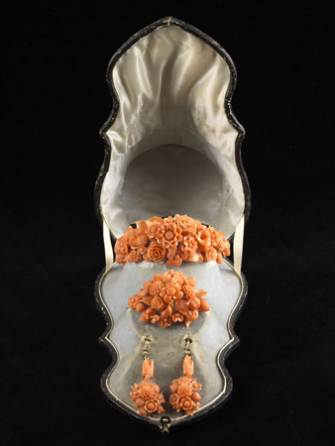 | 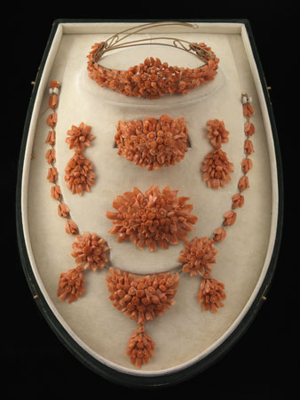
Figure 7: Demi parure "flowers & leaves" Sciacca coral. Manufacture in Naples, last quarter of 19th century ©LucianoPedicini
Parure "flowers & leaves" Sciacca coral. Manufacture in Naples, last quarter of 19th century.©LucianoPedicini.

The discovery of precious coral in Asia, particularly in Japan in 1871 and Taiwan in 1923, as well as in Hawaii on the Pacific in the 1960’s, not only created new traditions and cultural heritage in the local communities, especially in Kochi, Japan, but further contributed to the development of a solid coral industry in Torre del Greco where the know-how was highly recognised, a fame that still stands today. Impressive precious works were encouraged by the importation of coral from Japan which, due to its larger size and more compact structure, was better suited to the plastic arts. Products made from Japanese coral tried to outdo sculpture, oscillating between neo-classical themes and Art Nouveau influences, without ignoring the clear references to Pompeian art.
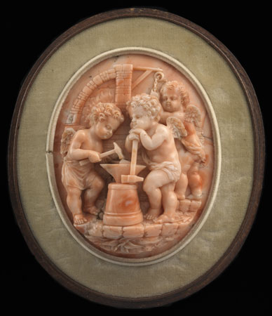 | 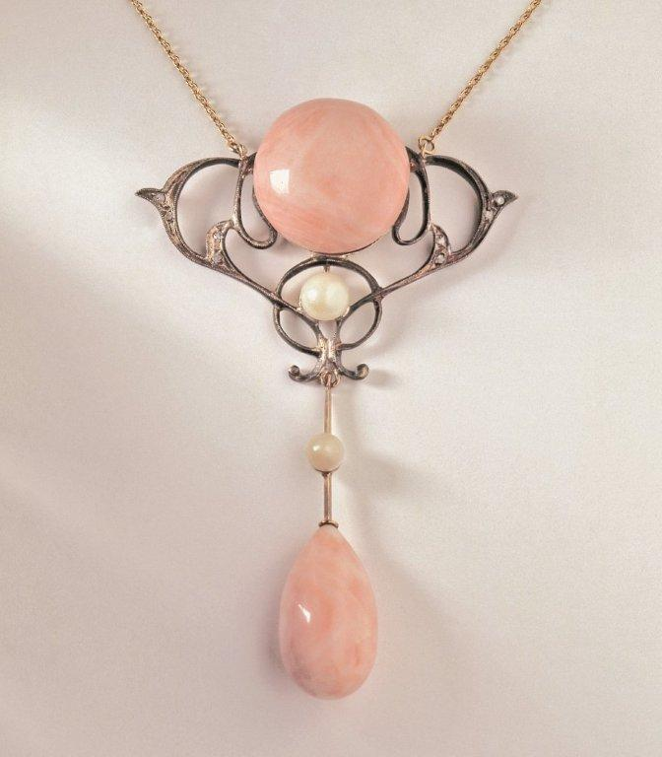
Figure 8: Cameo portraying "Cupid's forge", Pacific coral. Manufactured by Capuano firm,Naples. late 19th century. ©Lucianopedicini
Necklace pendant Art Nouveau, Pacific coral, gold, silver, pearls. Manufactured by Ascione. Early 20th century © ASCIONEtorredelgreco1855

Some noteworthy artefacts

Coral Reliquary of the Saint Queen of Portugal
One of the most significant examples of Iberian goldsmithery is this unusual 14th century reliquary of the True Cross kept at the Machado de Castro National Museum, Coimbra. The piece belonged to Isabel of Aragon (1270-1336), queen consort of Portugal (canonised in 1625), whose vast personal treasure included this reliquary, and was bequeathed to the Santa Clara-a-Velha Monastery in Coimbra, whither she retired in reclusion following king D. Dinis's death. Besides the unusual exotic and organic form of the whole, the various branches of red coral are noteworthy as their size and vivid red colour are outstanding, considering that these are Mediterranean precious corals (Corallium rubrum).
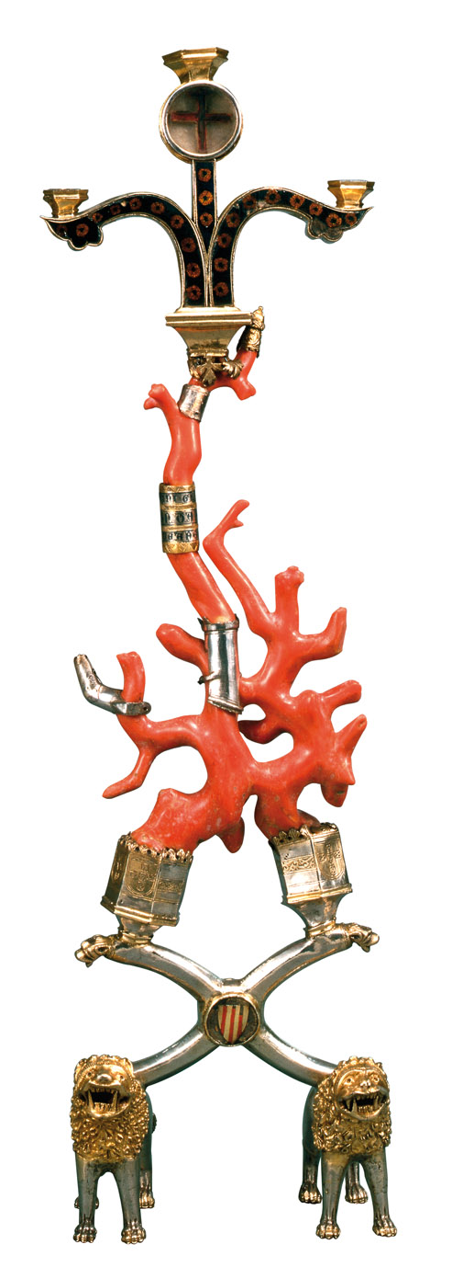
Figure 9: The 14th century True Cross Reliquary, in silver gilt, enamel and Corallium rubrum branches that belonged to Queen Saint Isabel from Portugal (1270-1336). Museu Nacional de Machado de Castro © Direcção Geral do Património Cultural

Figure of musician from the "Mountain of coral"
This small but superb sculpture (Figure 10) was part of a larger set, with figures in various roles, as in the traditional nativity scene made in Trapani, Sicily. At the end of 1500's coral sculpture reached high artistic level thanks to a good incentive introduced by sculptors. The famous Mountain of coral has been gift from the Spanish Viceroy in Sicily, to the King of Spain, Philip II. It must have been a huge composition, containing at least 85 figures, costing a good four hundred ounces, a work lost, of which a precise description by the Grand Treasurer Don Pietro Di Gregorio, Secretary General of the Kingdom remains, in which he bore witness to how even in those days the art of coral working in Trapani was flourishing and varied in its subject matter, technical invention and stylistic features.
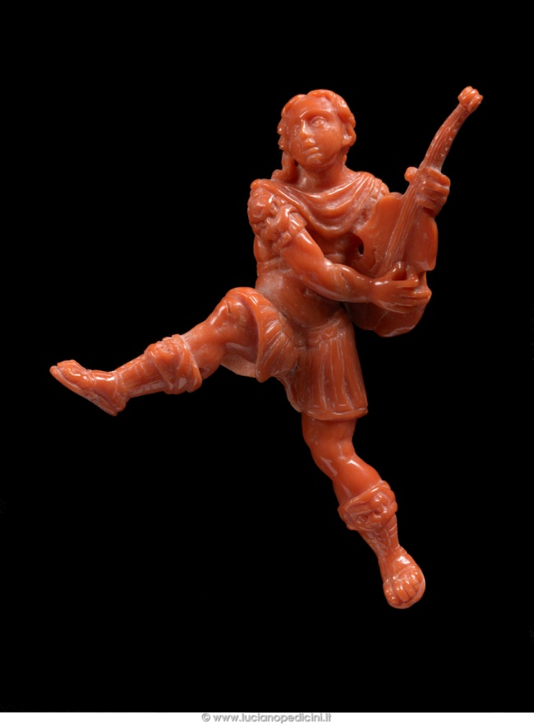
Figure XX: Figure of musician from the "Mountain of coral" in Mediterranean coral, manufactured in Trapani, Sicily (late 16th to early 17th century). Museo Nazionale della Ceramica Duca di Martina (inv. n. 397), Naples © LucianoPedicini

Casket with writing set
This extraordinary casket from the second half of 17th century shows its splendour through its remarkable size (26 x 45 x 38 cm) and the powerful decoration of coral sculptures that appear in profusion over the whole surface. The intricate racemes, rosette and volutes, and the allegorical scenes are all motives typical of the late mannerist workings of Trapani, in Sicily. The cover is decorated at the centre with a noteworthy round sculpture representing the image of God the Father giving his blessings wearing loose baroque drapery and holding the World.

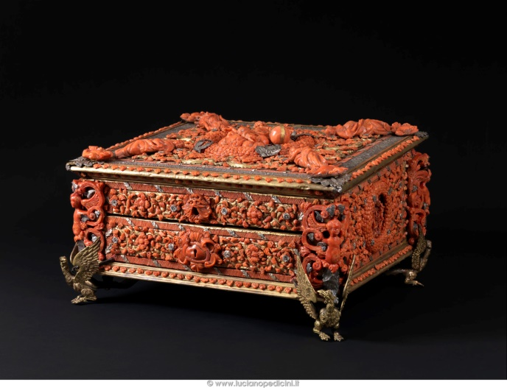 | 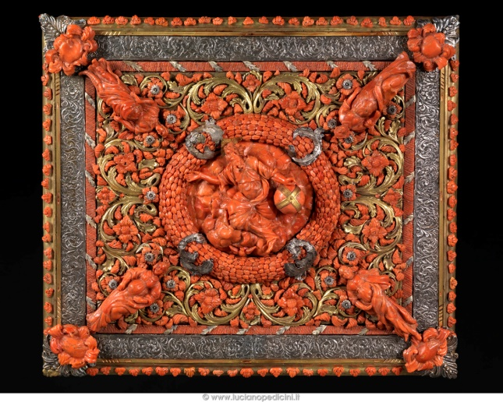
Figure 11: Casket with writing set. Wood, silver, gilded copper, Mediterranean coral, (22 - 26 x 45 x 38 cm.) Manufactured in Trapani, Second half of 17th century. Private collection, Palermo, Italy. © Luciano Pedicini

Large Salt Shaker
The precious salt shaker is a rare example of great workmanship by coral artists in Trapani during the late 16th century. The triangular base, in gilt copper, is supporting a remarkable huge branch of coral (diameter 9 cm.) sculptured with complex allegorical subjects, tritons and human figures, seahorses and mermaids, shells and hours heads that enrich the metaphoric symbolism of the 16th century art. The piece, (kept at Museo Pepoli in Trapani, Italy) is a masterpiece used in a noble household as precious furnishing during feasts and celebrations.

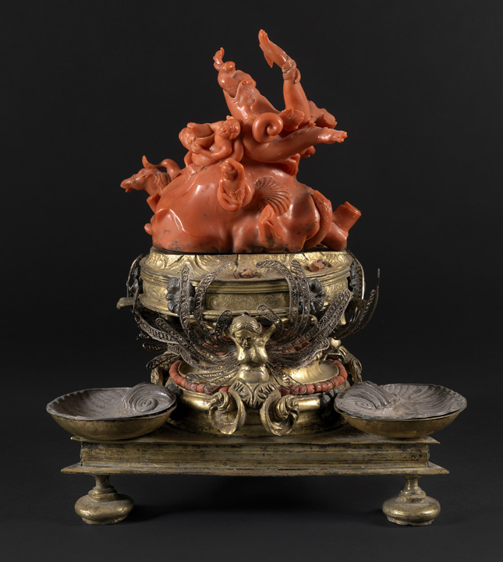 | 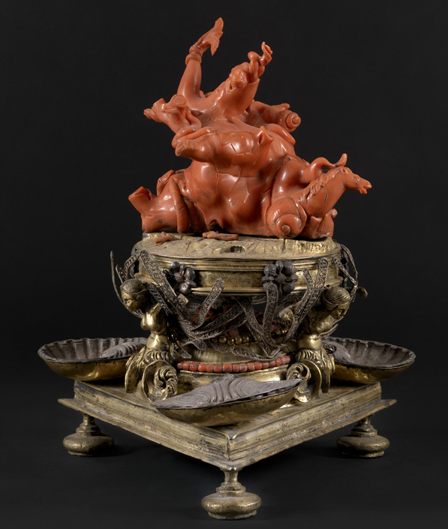
Figure XX: Large Salt Shaker. Gild copper, Mediterranean coral (height 6 cm., diameter 5 cm). manufactured in Trapani, late 17th century. Museo Nazionale della Ceramica Duca di Martina (inv. n. 393), Naples © LucianoPedicini

Holy Water Vessel with Saint John the Baptist
This precious holy water vessel, from the beginning of 17th century, is a masterpiece made by coral artist from Trapani. The vessel is arranged around a central space that contain the image of the saint, in a decoration of curls, pods, crosses inserted in the gilt copper plate using the retroincastro technique, typical of the earlier Trapani style. The fretwork motif recalls the richness of the phytomorphic (vegetalistic) carpet decoration that adorns the median part of the work, a characterization typical of the Holy water vessel of Trapani production at the first half of the 17th century.
The tray also incorporates the overall decoration and ends with an unusual and important sphere in multifaceted amber, a detail not common to other coeval creations. Today is kept at Museo Liverino at Torre del Greco.
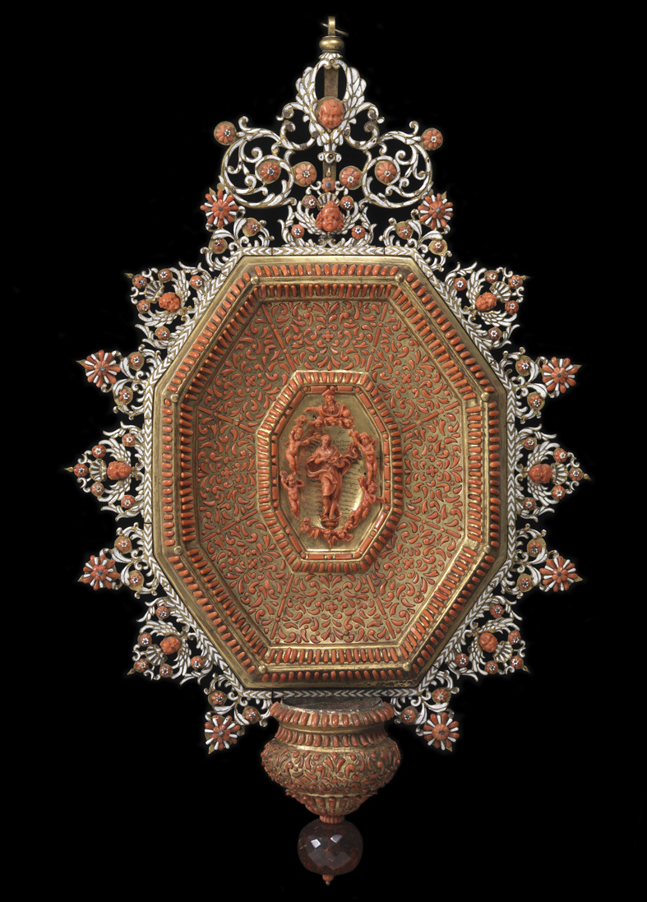
Figure xx: Holy Water Vessel with Saint John the Baptist, Gild copper, Mediterranean coral, enamels, amber. (58 x 35 cm). Manufactured in Trapani, first half of 17th century. Museo Liverino collection, Torre del Greco © LucianoPedicini

Napoleon's I Ceremonial Sword
The gold ceremonial sword that belonged to Napoleon Bonaparte is a marvellous work of two artistic skill, the French armourer M. G. Biennais, who made the gold chiselled handle, and the ten coral cameos made by the "Real Fabbrica" (regal factory) of P. B. Martin in Torre del Greco. The coral cameos were commissioned by Caroline Bonaparte Murat, Queen of Naples from 1808 to 1815, to Martin as a gift to her brother Napoleon the Emperor. The cameos depict both ancient and mythological subjects as well as portraying several members of the French Imperial family, in the centre of the sword guard is the profile of Carolina Bonaparte and at the centre of the handle is Letizia Bonaparte, Napoleon's mother, both portraited in Greek style dresses and ornaments. Skilfully carved in the neoclassical taste, these objects excited the enthusiastic admiration of Caroline Bonaparte Murat, who conveyed her passion for coral to the Napoleonic court.
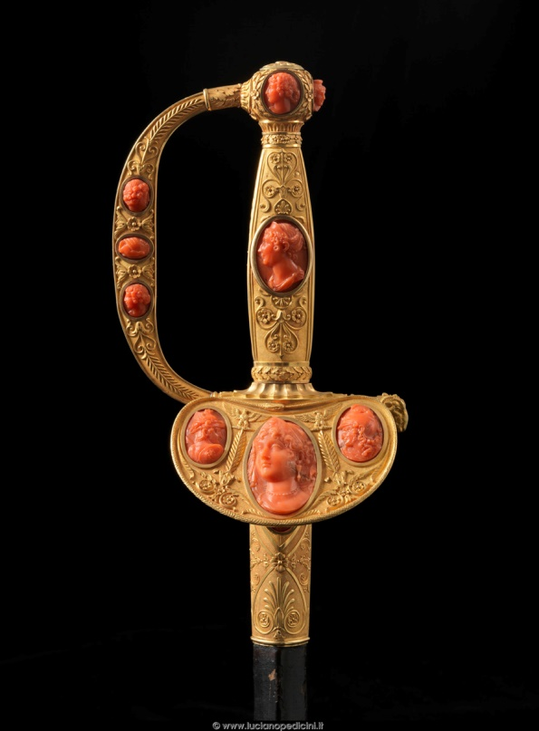 | 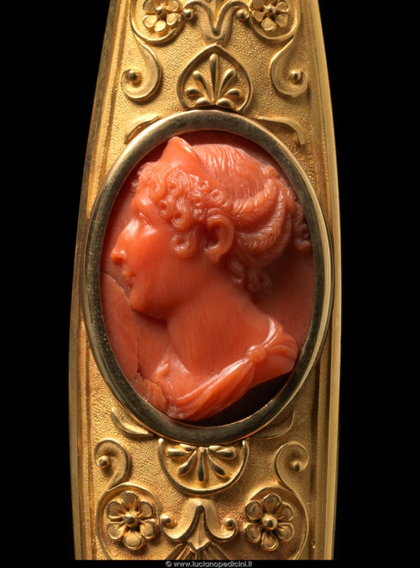
Figure xx: Napoleon's I Ceremonial Sword. Gilded copper, iron, gold, Mediterranean coral. Manufactured by Biennais in 1798 and 1809. Cameos made by Real Fabbrica de’ Coralli Paul Barthèlemy Martin, Torre del Greco, 1808 – 1809. Musée National du Château de Fontainebleau, France © LucianoPedicini

Corals as Plants?
Key concepts
In Antiquity, corals were believed to be stony plants or something between plants and animals
The true animal nature of corals was only discovered and accepted in the 18th century
Today corals are considered part of the Animal kingdom

For millennia, corals were believed to be stony plants (lithophyta, from the Greek lithos, stone, and phytos, plant). Aristotle (ca. 383-322 BC), the famous Greek philosopher, for example, classified corals in between plants and animals, classifying them as zoophyta (from the Greek zoo, animal, and phytos, plant). The arborescent morphology of the branches associated with the lack of microscopic evidences to hypothesise otherwise, were in the base of such a belief that was published continuously, even in more modern, but yet early, oceanographic treatises, like in the count Luigi Ferdinando Marsigli’s (1658-1730) Histoire Physique de la Mer in 1725.
At about the same time as the publication of this treatise, coral was finally recognised as an animal and not as plant, a theory that the famous Persian scholar Abu Al-Biruni (973-1048) already defended about seven centuries before. Only in 1726 after the research made by French naturalist Jean-André Peyssonnel (1694-1759) that worked closely with count Marsigli in Bologna, was the animal nature of corals accepted. This was further supported by Sir William Hershel’s (1738-1822) observations of living corals under the microscope where the animal nature of those species was confirmed.

Corals as Gem Materials (CIBJO Nomenclature)
Before the current terms and definitions related to corals as recognised as a trade standards by CIBJO, it is important to introduce CIBJO in more depth.

What is CIBJO?
CIBJO is the French acronym for the Confédération Internationale de la Bijouterie, Joaillerie, Orfèvrerie, des Diamants, Perles et Pierres, which in English translates to the International Confederation of Jewellery, Silverware, Diamonds, Pearls and Stones. It was founded in 1926 as BIBOAH, reorganised in 1961 and renamed CIBJO and in 2009 it was named “CIBJO, The World Jewellery Confederation”. CIBJO is a non-profit confederation of national and international trade associations including commercial organisations involved in the jewellery supply chain. It now has members from countries representing all five continents of the world. It is also an organization recognized by the United Nations in the United Nations Economic and Social Council (ECOSOC) with a Special Consultative Status, being also member of the UN Global Compact.
It is the task of CIBJO to record the accepted trade practices and nomenclature for the industry throughout the world. The purpose of CIBJO is to encourage harmonisation, promote international co-operation within the jewellery industry, consider issues which are of concern to the trade worldwide and to communicate proactively with members. Foremost amongst these the aim is to protect consumer confidence in the industry.
The work of CIBJO is accomplished through Committees, Commissions and Sectors. Committees and Commissions consider standards for use in the jewellery supply chain. Sectors represent levels of trade in the jewellery industry. Three independent sectors exist within the confederation: Sector A — The Products Sector; Sector B — The Supply Chain Sector; Sector C — The Service Sector; and at present these are 9 working commissions: Coloured Stone, Coral, Diamond, Ethics, Gemmological, Pearl, Marketing & Education, Precious Metals, World Jewellers Vigilance.

The Sectors and Commissions will propose changes in the standards, also known as the Blue Books, to the Executive Committee. After review the Executive Committee will submit the accepted proposals for adoption to the Board of Directors and if approved they will notify the assembly of delegates of the changes at the annual congress. Furthermore, it is our mutual responsibility to support these recommendations, which concern all professional people connected with coral, diamonds, gemstones, pearls and precious metals. CIBJO Standards are subject to government regulations in the respective jurisdictions of CIBJO members.

CIBJO Blue Books
The CIBJO Blue Books are definitive sets of grading standards and nomenclature for diamonds, coloured gemstones, pearls, coral, precious metals, and gemmological laboratories. They are compiled and are consistently updated by the relevant CIBJO Commissions, whose members include representatives of trade organisations and laboratories active in the diamond, coloured gemstone, pearl, precious metals and jewellery industries. The Blue Books are therefore living documents that are subject to review periodically for revision or reaffirmation.
The standards represented a consensus derived from the broad expertise on the subject within the commissions, and also from individuals outside the commissions who had expressed an interest in participating in the development of the guidelines. Presently, there are six Blue Books for Diamonds, Gemstones, Pearls, Corals, Precious Metals and Gemmological Laboratories. The Coral Book was first launched in 2015 and ratified in 2016.
In almost complete absence of jewellery industry standards endorsed by the International Standards Organisation (ISO), the CIBJO Blue Books are the most widely accepted set of globally accepted standards. The application of the Blue Books’ standards is voluntary. However, it is recommended that these standards should apply to all persons, partnerships and corporations at all stages of the jewellery chain of distribution, from the initial sourcing of all industry products up to and including the creation of jewellery and objects d’art, where applicable.

CIBJO Terms and Definitions for corals
The following definitions are taken from Clause 3 of the 2017 CIBJO Blue Book:
Classification of Materials
The jewellery industry recognises two categories of materials: natural materials, and artificial products.
Natural materials
Corals - Cnidarians with skeletons are referred to collectively as “coral”. Corals are marine invertebrates formed by nature without human intervention. Corals may have been subsequently modified by normal lapidary practices.
Precious corals - Precious corals are those that are used in jewellery and decoration, specifically red, pink and white varieties with porcelain like lustre after polishing. They are limited to species belonging to the family Corallidae, consisting of the three following groups: Corallium, Pleurocorallium and Hemicorallium. They have a specific gravity of approximately 2.8 and a hardness of 3 ½ on Mohs scale.
Common corals - Common corals are mostly of calcareous type, usually found in the coral reef e.g., sponge coral, bamboo coral and blue coral. After treatment, some species are sometimes used as ornaments.
Treated corals - Corals which have been treated to change their appearance and/or durability.
Artificial products - Products that are partially or completely made by man.
Imitations of corals - Artificial products that imitate the appearance of natural materials, without having their chemical composition and/or their physical properties or their structure.
Artificially produced composite stones - Composite products composed of two or more previously separate parts or layers assembled by bonding or other artificial methods. Their components can be natural and/or artificial.
Reconstructed corals - Pieces of coral bonded together.
Other artificial products - Artificial products that imitate the appearance of corals.

More CIBJO gem related terms and definitions
Natural Substances
Gemstones - natural materials which have been formed completely by nature without human interference. They are usually used in jewellery or objects d’art due to a combination of properties that provide them with beauty, rarity and relative durability. They encompass:
Minerals (e.g. aquamarine, diamond, emerald, garnet, topaz, ruby, sapphire)
Natural glasses (e.g. obsidian, moldavite)
Rocks (e.g. lapis lazuli, opal with matrix, aventurine quartz, jadeite jade)
Organic gem materials (e.g. amber and tortoiseshell)
Biogenic gem materials (e.g. pearl, coral and mother-of-pearl)
Note: Only materials that have been formed completely by nature without human interference/intervention qualify to be described as “natural”. The unqualified terms, “ruby”, “emerald” and other gemstone names, may only describe a gemstone of natural origin. The adjectives “real”, “precious”, “genuine” or “natural” shall only be used to refer to or designate natural materials.
Treated gemstones - A gemstone may be modified by normal lapidary practices but all gemstones that have been subjected to a treatment, usually to change their colour, durability, stability, and/or clarity, shall be declared as treated gemstones by simply stating, “treated ruby”, “treated emerald”, etc., or by stating the specific treatment type, “heated ruby”, “dyed emerald”, etc.
Note - The treatment of some gemstones is undeterminable, such as heat treated aquamarine and tourmaline or some irradiated beryl and tourmaline. In such case it is prudent to disclose any possible treatments.

Artificial Products
These are products which include a variety of materials that are partially or completely made by man.
Artificial products partially made by man - These are composite stones with gemstone components, examples of which include “garnet-topped-doublets”, “emerald on glass-doublets”, “natural sapphire on synthetic ruby-doublets” as well as “ruby-glass composites”, “pressed amber” and “emerald on emerald-doublets”, or “composite diamonds” (diamond on synthetic diamond).
Artificial products completely made by man
Synthetic stones - synthetic stones encompass those materials that are defined as being artificial products having essentially the same chemical composition, physical properties and structure as that of their naturally occurring counterparts; examples which are commercially available include “synthetic diamond”, “synthetic ruby”, “synthetic sapphire”, ‘synthetic emerald’, and “synthetic amethyst”.
Note – The term “synthetic” “laboratory-created” and “laboratory-grown” are synonymous
Artificially crystallised products with no known natural counterpart -These include, e.g., yttrium aluminium garnet (YAG) and gadolinium gallium garnet (GGG).
Artificial uncrystallised products - These include man made glass, lead glass, plastic and products of various compositions, such as pressed materials (e.g. pressed turquoise) etc., that are used to imitate the appearance of gemstones.

Biogenic versus organic gem materials
Since the dawn of gemmological education in the second quarter of the 20th century that gem materials have been organised in such a way that it is common to separate categories like diamonds, coloured gemstones and organics. In the organics we can see a list of gem materials that originated from the activity of living organisms, e.g. ivory, bone, coral, tortoise shell, pearl, mother-of-pearl, shell, horn, corozo (vegetable ivory) and copal just to name the most important ones. It happens though that the word “organic” may has specific meanings rather than a broader statement of material that was generated in a living organism (e.g. a carbon based compound) and some scholars recognise that boundaries of the definition are somewhat arbitrary. Moreover, some of the gem materials grouped as organics are not, in any sense, organic in composition and that is the case of precious corals, pearls, cultured pearls, mother-of-pearl and shell. The major composition of the materials is biomineralized calcium carbonate in aragonitic and/or calcitic structures and carbonates, as crystal matter, are strictly speaking considered inorganic matter, not organic.
In the 2016 CIBJO Congress held in Yerevan, Armenia, these arguments were discussed and there was a consensus that the better word to describe those gem materials that originate from living organisms was “biogenic”, literally meaning that they result from biological activity. It may take some time to the trade and gemmological community to assimilate these concepts and to possibly embrace this new more accurate approach to the biogenic gem material’s nomenclature. It has been therefore suggested that precious corals are better termed as biogenic gem materials rather than organic gem materials.

Simplified Biology of Precious Corals
Key concepts
Corals belong to the Anthozoa class of the phylum Cnidaria, formerly known as Coelenterata
Coral is the collective name of more than 7000 species, but less than 10 are considered precious corals
Most precious corals belong to the Corallidae family

The word coral collectively applies to thousands (ca. 7300) of marine species of the phylum Cnidaria (formerly known as Coelenterata), Animalia kingdom, particularly those from the Anthozoa class, including many in the subclasses Octocorallia and Hexacorallia. Of these, only but a few are suitable for use in jewellery and decorative arts, being then separated into precious corals and common corals, sensum strictum.
The name “precious coral” that has been supported in the last few years by the trader’s community meant to properly separate these very few species from the species of common corals, but mostly from the numerous species of reef corals that do not have a place in the jewellery industry. According to the CIBJO Coral Book, precious corals are those that are used in jewellery and decoration, specifically red, pink and white varieties with porcelain like lustre after polishing. They are limited to species belonging to the family Corallidae (order Alcyonacea, suborder Scleraxonia), particularly from the Corallium, Hemicorallium and Paracorallium genera. Reef building corals, on the other hand, are defined as calcareous type, usually found in the coral reef that after treatment, can be sometimes used as ornaments. It happens that many of these coral species in coral reefs (e.g. blue coral - Heliopora coerulea) are protected and have been recently targeted as endangered by the worrying effects of climate change.
Other coral varieties, like sponge coral, bamboo coral, black and golden corals are considered common corals sensum strictum, not precious corals.
For the purpose of the jewellery trade, two major types of corals may be considered: precious corals and common corals. Reef corals, the majority of species of what is collectively designated as corals, have no representation whatsoever in jewellery.

Taxonomy of Corals
Covering the taxonomy of corals in a complete manner would fall outside the scope of this course. Having in mind that there is much science involved in the definition of the phylogeny all the species that can collectively be termed “corals”, a selection of the most important taxa (that is, biological groups of species) have been made to clearly give a perspective of the subject in light of the species that can be used, or were used in the past, as gem materials. Please refer to (XXXXXX) for further information on the biology of corals.

Anthozoa (class)
The name Anthozoa comes from the Greek words ánthos, flower, and zóa, animals, hence Anthozoa or “flower animals”. Anthozoarians lack a medusa stage. The basic unit of the adult is the polyp which consists in a sac-like body with an opening, the mouth, surrounded by stinging tentacles called nematocysts or cnidae.
Coral polyps can be solitary like sea anemones but most of them are colonial with polyps linked together. Corals secrete a skeleton made of calcium carbonate.

Octocorallia (subclass)  Comprises around 3,000 species of water-based organisms formed of colonial polyps with 8-fold symmetry. These organisms have polyps with eight tentacles and eight mesenteries and can possess an internal calcite skeleton secreted by mesoglea. | Ceriantharia (subclass)  tube-dwelling anemones but belonging to an entirely different subclass than sea anemones. | Hexacorallia (subclass)  Comprises approximately 4,300 species of aquatic organisms formed of polyps, generally with 6-fold symmetry. These organisms are formed of individual soft polyps which in some species live in colonies and can secrete an aragonite skeleton.
Orders  Alcyonacea (soft coral)  Soft corals contain minute, spiny skeletal elements called sclerites, useful in species identification. Sclerites give these corals some degree of support and give their flesh a spiky, grainy texture that deters predators. Unlike stony corals, most soft corals thrive in nutrient-rich waters with less intense light. Among them, the Corallidae family include precious corals which also produce a calcite skeleton: Corallium rubrum, Corallium japonicum, Pleurocorallium elatius, Pleurocorallium konojoi, Pleurocorallium secundum, Hemicorallium regale, Hemicorallium laauense and Hemicorallium sulcatum.  Helioporacea (blue coral)  Forms massive lobed crystalline calcareous skeletons in colonial corals. It has no spicules and is the only octocoral known to produce a massive skeleton formed of fibro crystalline aragonite fused into lamellae, similar to that of the Scleractinia (stony corals).  Pennatulacea (sea pens)  Unlike other octocorals, however, a sea pen’s polyps are specialised to specific functions. Comprises 16 families. | Orders  Penicillaria  Spirularia | Orders  Actiniaria (sea anemones)  A group of water-dwelling, predatory animals. Comprises 46 families.  Antipatharia (black coral)  group of deep water, tree-like corals related to sea anemones.  Corallimorpharia  Closely related to stony corals (Scleractinia). Contains 46 species, inside 10 genera in 4 valid families.  Scleractinia (stony corals)  Also called hard corals. Scleractinian corals may be solitary or colonial. Consists of 35 families.  Zoantharia  Zoanthids can be distinguished from other colonial anthozoans and soft coral by their characteristic of incorporating sand and other small pieces of material into their tissue to help make their structure (except for the family Zoanthidae). Consists of 7 families.
Note: precious corals in red

Table: Simplified Taxonomy of Precious and Common Corals*
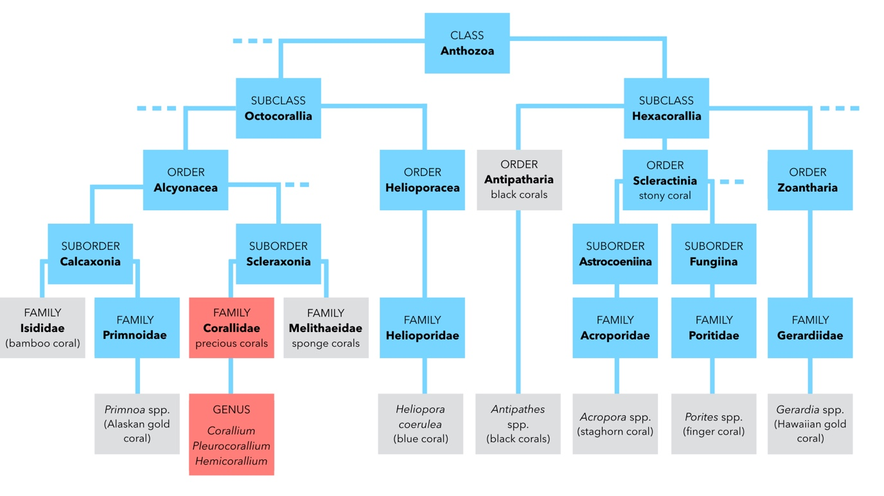
* precious corals in red, common corals in grey

Precious Coral versus Reef Coral
Key concepts
Precious corals are usually deep water species (between 50 – 2000 meter), while reef corals live in shallow water
Precious coral species are a very small percentage (less than 0,2%) of the total coral species (Class Anthozoa)
Climate change has been especially detrimental to reef corals in shallow water, but these are not used in jewellery

Not all corals are used in jewellery, in fact only a very limited number of species have been used as gem materials. A significant number of (delete majority) of living corals live in coral reefs at shallow depths of a few meters and the corals used in jewellery, hence called “precious corals” are harvested in much greater depths and in different marine ecosystems that the reef corals. There are more than 3300 species of deep sea corals, some at depths of 6000 meters, but the vast majority is not used in jewellery. From the circa 7300 species of corals, less than 10 are considered precious corals and used in jewellery (less than 0,2%) and these all belong to the Corallidae family, e.g. genus Corallium, Hemicorallium and Pleurocorallium.
One major difference between precious corals and most reef building corals lies on the depth where they occur and can be harvested. Common corals in coral reefs live in shallow waters whereas precious corals live in greater depths and are harvested bellow 50 meters, up to 2000 meters deep. It is important, therefore, to understand and to properly convey that the corals used in the jewellery industry, here mentioned as precious corals, are not the same as the corals in coral reefs, that have no use in jewellery. Climate changes are being particularly threatening to the reef building corals and a great concern of biodiversity and environmental organisations, deserving the utmost attention of the world population.
As a collective term, “coral” has been used to describe most of the cnidarians of the Anthozoa class. The recent media exposure of the endangered corals in the great reef barrier and elsewhere (e.g. Florida) have introduced a negative impact on the word coral as a product. Attending on the afore mentioned differences, a clarification was needed in separating both ecological realities, notwithstanding the fact that CITES, environmental organizations and several governments have taken steps to minimize the impact of precious coral harvesting and promote its sustainability for the future. it is, therefore, imperative that the corals used in jewellery are termed “precious corals”, as suggested by the CIBJO - The World Jewellery Confederation.
Note: In some instances, the expression “semi-precious” corals is seen. The current gem and jewellery trade nomenclature does not recognise the term “semi-precious” for corals or for any other gem material.

Common corals
As previously mentioned, in jewellery and decorative arts there are more coral species that have been used other than precious corals. These include mostly calcareous types, like sponge corals, bamboo corals and blue corals that after treatment may be used as ornaments. Black and golden corals, with non-calcareous exoskeletons, are also considered here as common corals.
Strictly speaking under the trade current terminology standards, apart from precious corals belonging to the Corallidae family, the other few corals used in jewellery and decorative arts are classified as common corals, regardless of their depth and area of occurrence.

Precious Coral Varieties
Key concepts
Precious corals belong to a limited number of species of the Corallidae family
Depending on the species, colours very between deep red and white, as well as various hues of pink and orange, sometimes with white patches and uneven colour distribution
Sizes of branches depend mostly on the species and age.
The largest precious coral variety is the Pleurocorallium elatius that, depending on colour, is known in the trade as cerasuolo or angel’s skin.
Angel’s skin is a trade term for the albino variety of Pleurocorallium elatius
Sciacca coral is the trade term for the orangey dead coral branches found in 1885 off the coast of Sciacca in Sicily, Italy
Mediterranean coral, that also thrives in the nearby African and European coast, is famous for its deep red colour, history and is known in the trade as Sardinian coral.

As previously mentioned, there are only few species of coral that are used in jewellery and their colours don’t vary much from the white to orange or white to red tones. Each coral variety can be traced to the specific taxon (biological group) that generated it, but the coral community commonly refer to corals by their trade names and these vary with the geographic variations of local vernaculars. These vernaculars and trade names are the ones that are transmitted through the supply chain and that the consumer see on tags at the retail level. Identifying a gem as a precious coral is not a hard task for the experienced gemmologist or jeweller, but properly identify the species that originated it is only for the specialist and trained gemmologist at the laboratory. Sometimes, the same species originates material with different trade names due to their different colours and colour distribution. More and more, the consumer and the jeweller request specific information about precious corals particularly on their varieties that are related to the species that originated them. This has to do with the different value perceptions that the different types of coral have on the market. It is, therefore, important to present the different precious coral varieties.

Aka, Moro or Oxblood
Dark red to very dark red corals with a lengthwise white interior, sometimes called “soul”, corresponding the branches of Corallium japonicum that live in depths of 80 to 300 meters in Japanese waters. In average, this fan-shape coral has a height of 20 cm, a trunk diameter of 12 mm and a 200 g weight.
Dark red saturated, oxblood coloured, beads or cabochons are among the most sought after precious coral varieties worldwide, especially in large sizes that are exceedingly rare. Aka means “red” in Japanese.
Exceptional sizes:

Momo, Cerasuolo or Satsuma
Bright red, salmon, orange and flesh colour with a lengthwise white interior, corresponding to the branches of Pleurocorallium elatius (also known as Corallium elatius) that lives in depths of 150 to 350 meters in Japan and Taiwan. In average, this fan-shape coral has a height of 35 cm, a trunk diameter of 25 mm and a 500 g weight. In some cases, the branches can reach sizes of over 1 meter, being the largest type of precious coral.
The large artistic coral carvings, namely of oriental manufacture, are usually made in this type of precious coral. The name “momo” stands for peach in Japanese and “cerasuolo” is a generic Italian term usually seen in cherry red coloured rosé wines.
Exceptional sizes:

Angel Skin, Boké or Magai
Delicate flesh pink with different colour intensity, corresponding to the branches of a rare variety of Pleurocorallium elatius (also known as Corallium elatius) that lives in depths of 150 to 300 meters in Japan, Taiwan, Hainan and Hong Kong. In average, this fan-shape coral has a height of 35 cm, a trunk diameter of 25 mm and a 500 g weight.
The gracious pink colour of this almost albino precious coral has many fans in the high-end jewellery segment and it is, probably, the most popular coral variety after the traditional Mediterranean red coral.
Exceptional sizes:

Pure White or Shiro
Milky white, sometimes with red or pink specks, corresponding to the branches of Pleurocorallium konojoi (also known as Corallium konjoi) that lives in depths of 80 to 300 meters in the South China Sea and Hainan. In average, this fan-shape coral has a height of 35 cm, a trunk diameter of 25 mm and a 500 g weight.
In shape this coral is somewhat similar to Momo and Boké, but the colour is overall white, hence the name shiro in Japanese.
Exceptional sizes:

Midway, Rosato or White/Pink
Veined white or pink, sometimes with red specks, or uniform clear pink, corresponding to the branches of Pleurocorallium secundum (also known as Corallium secundum) that lives in depths of 400 to 600 meters in Hawaii and Midway Island. In average, this fan-shape coral has a height of 25 cm, a trunk diameter of 15 mm and a 200 g weight. The Italian term “rosato” (rosé wine) refers to the rose colour of the Midway corals similar.
Exceptional sizes:

Deep Sea or Shinkai
Bright white, clear pink or white pomegranate with red veins or spots, corresponding to the branches of Hemicorallium laauense (sometimes suggested as Corallium secundum) that lives in depths of 1000 to 2000 meters in Midway, NW of Emperor Seamount. In average, this fan-shape coral has a height of 30 cm, a trunk diameter of 10 mm and a 150 g weight.
The most striking characteristic of these corals is the colour distribution, where a uniform white to pink background is decorated with reddish veins, cracks or spots caused by the change in water pressure and temperature from great depths to the surface.
Exceptional sizes:

Garnet
Pomegranate colour with different shades of uniform pink, corresponding to the branches of Hemicorallium regale (sometimes suggested as Corallium secundum) that lives in depths of 350 to 600 meters in Hawaii. In average, this parallel-shape coral has a height of 15 cm, a trunk diameter of 8 mm and a 100 g weight.
Usually small in size, this precious coral variety is distinguished by its characteristic colour, hence the “garnet” name.
Exceptional sizes:

Misu, Missu or Miss
Pink to violet uniform colour, corresponding to the branches of Hemicorallium sulcatum (sometimes suggested as Corallium secundum) that lives in depths of 100 to 300 meters in the North of the Philippines. In average, this fan long-shape coral has a height of 25 cm, a trunk diameter of 15 mm and a 200 g weight.
Exceptional sizes:

Sardinian or Mediterranean
Uniform red with medium to strong saturation, corresponding to the branches of Corallium rubrum that lives in depths of 50 to 1000 meters in the Mediterranean and off the coast of Northern Africa in Atlantic areas, including the Canary Islands and Cape Verde. In average, this bush-shape coral has a height of 15 cm, a trunk diameter of 8 mm and a 100 g weight.
Exceptional sizes:
Most historical artefacts are embellished with corals sourced from this precious biogenic material in the Mediterranean. It is the most popular coral variety and is associated with a red colour that has tradition

Sciacca
Orange, pink and dark “smoky” orange colour, corresponding to the branches of Corallium rubrum that are deposited in geological sediments at various depths in the south of Sicily. The deposits were discovered in the late 19th century. In average, these often broken branches or trunks have a height of 7-10 cm and a trunk diameter of 5 mm. These corals are collected as sediments, not as a product of harvest. Similar deposits have been reported in Alboran, south of Spain.
It is interesting to notice that these marine deposits with dead corals have a geological origin and are considered sedimentary formations.

Dead coral
Dead coral is a general term that is applied to precious coral branches whose colony is no longer alive but that, due to the durability of calcium carbonate, has been able to remain tough enough to be used in the jewellery industry. The afore mentioned deposits in Sciacca and Alboran are two typical cases. Along the sea beds of Japan and Taiwan, branches of Corallium japonicum and Pleurocorallium elatius have been harvested in these conditions, being thus considered dead coral. In Japan, dead corals with ages between 5600 BC and 1890 AD have been reported after carbon dating research. It was also verified that the colour of coral is affected by such long age and deposition on the sea bed and parasite perforation might be present.

Common Coral Varieties
Key concepts
Non-precious corals, defined as common coral in the trade standards, may also be used as ornaments
Some of these species are protected under CITES, e.g. Antipathes spp. (black coral), Heliopora coeruela (blue coral), lace coral (Stylaster genus)
Treatments (e.g. dying, impregnation) are usually done to make common corals suitable for adornment purposes

There are a few species of non-precious corals that are used as ornaments and some of them are included in CITES Appendix II.

Bamboo coral
Also known as mountain coral, it belongs to the family Isididae (subclass Octocorallia) including species of the genera Isis, Lepidsis and Acanella. Bamboo coral has a flexible and segmented structure composed of white calcareous trunks and dark keratinous gorgonian nodes, resembling bamboo canes, hence the name. The white calcareous component is commonly died pink or red. Occurs in the Pacific Ocean, namely in Tasmania, New Zealand and USA.

Black coral
Colonial corals of a very dark brown to black colour that form non-calcareous skeletons composed of protein and chitin that are quite flexible, spiny, tree like, unbranched or branched belonging to the order Antipatharia (subclass Hexacorallia). These have a much lower specific gravity that the calcareous corals (SG ≈ 1,34) and can be beached to obtain golden coloration. Common trade names include accarbaar, akabar and king coral. They occur almost worldwide, especially in strong current environments at depths up to 6000 meters.
All corals belonging to the Antipathes genera (Antipathes spp.) are listed in Appendix II of CITES.

Golden Coral
The name golden coral refers to natural golden coloured non-calcareous varieties of two types of common corals, namely species of the family Primnoidae) with characteristic ring growth structures that occur at various depths, up to 1000 meters or more, in Alaska, USA; and species of the family Zoanthidae, specially the Kulamanamana haumeaae, also with characteristic growth structures that lives at depths of 340-580 meters in Hawaii that, after polishing, acquires characteristic sheen effects. Bleached black coral (Antipathes spp.) may simulate these two types of golden corals.

Blue coral
These reef building of calcareous composition corals belong to the family Helioporidae (subclass Octocorallia), specially the Heliopora coerulea. It has a distinct blue colour, with a rough and porous skeleton that usually requires resin impregnation to be used as ornament. Occurs in Indo-Pacific shallow waters and, as a reef building coral, is protected and almost never seen today as a gem material. This species is listed in a CITES Appendix II.

Sponge coral
These natural sponge like corals belong to the family Melithaeidae (order Alcyonnacea) and are very porous requiring stabilisation treatment with impregnation and filling with resins or polymers before being polished. In addition to being filled, some material is also dyed, and a small amount of sponge coral has reportedly been crushed up and mixed with epoxy to be formed into desired shapes. It occurs mainly in Taiwan and Indonesia. Trade names include natural Congi, “red spongy coral” and “red king coral”.

Lace corals
Pink-to-red branches produced by the Stylaster genus, a species from the Sylasteridae family, have similar visual characteristics than some precious corals and have been known as lace corals. Apart from a totally different taxonomy and geographic distribution, these have a different compositions (aragonitic skeleton, compared with the calcitic skeleton of Corallidae species) and are usually dyed and impregnated to imitate precious corals. All of these species are listed in Appendix II of CITES since 1990, so their presence in the jewellery industry is very limited.

Coral Processing and Fashioning
Key concepts
Normally, the first stage of processing involves washing and separation according to shape, size, colour and colour distribution.
The most common outcome for precious corals are drilled beads, cabochons and carvings from simple small elements (e.g. vegetalistic shapes) to the most intricate sculptures.
The most historically important manufacturing location is Torre del Greco, near Naples, Italy
Hand manufactured precious corals are still available, but mechanisation has been replacing manual manufacturing

After harvesting according to the different fishing regulations in the various jurisdictions (see later), precious coral is properly washed and separated according to shape, size and colour, or colour distribution. Then, a decision is made on what to do with the raw trunks and branches and a primary cutting is performed to individualize rough material for further fashioning stages.
One of the most common solutions are spherical or non-spherical drilled beads that start with a piercing stage followed by smoothing, polishing, final polishing with colourless wax or paraffin, and subsequent stringing. A traditional way to polish precious coral uses natural pumice powder (obtained from the very light and porous volcanic rock that occurs namely near Torre del Greco, on the slope of the historic Vesuvius volcano). Small fragments of precious coral can be used in the polishing stage in order to obtain an optimised polish. Traditionally, the manufacture of round drilled beads was entirely made by hand, and some special precious coral beads still are today, but the bulk of the production has some sort of mechanisation.
Cabochons , a simple style of cut that usually has a flat base and a domed polished top in several contours (e.g. round, oval, pear) are also popular solutions for jewellery application, especially in the more costly varieties in larger sizes (e.g. angel skin, oxblood, Sardinian).
Fine craftsmen and sculpturing artists in Europe, but specially today in China and Japan, have contributed to the heritage of precious coral with fabulous creations of both pagan, more prosaic or more religious significance. In the Museo del Corallo, in Torre del Greco, there is a rare selection of ancient and modern day sculptures in precious coral, sometimes associated with other materials and signed by famous artists.

Value Factors
Key concepts
As with other gem materials, precious corals can be graded according to several criteria that slightly differ according to their varieties
The quality of fashioned precious coral depends on colour, colour distribution, lustre, surface quality, size and symmetry
It takes long years of experience to properly grade precious corals

As with diamonds, pearls and other coloured gemstones, there are a few main criteria that are important in the evaluation of precious coral. It must be emphasised that every precious coral variety has these factors adapted to, for instance, the particular set of colours and sizes in that occurs. Nevertheless, the main factors are colour, colour distribution, lustre, surface quality, size and symmetry. It takes long years of experience to properly grade precious corals and, contrarily to diamonds, there are not internationally accepted standards for coral grading.

Colour
Depending on the variety, the preferred colour varies. For example, red hues are much more appreciated than orange hues in Mediterranean coral, Corallium rubrum. Darker saturated reds are much appreciated in oxblood coral, Corallium japonicum, and a flesh light pink hue is high popularity in the angel skin variety of Corallium elatius.
It is interesting to note that each country has preferred colours. For example, in France light red is highly regarded and in Germany medium red.

Colour distribution
The greater the uniformity of the colour, the higher the value. In Mediterranean coral, colour is almost always uniform. In oxblood coral, for example, the presence of the large whitish core, although a valid diagnostic feature, is not commercially desirable. In other precious corals, especially in angel skin, it is very rare to obtain uniform pink colours throughout the bead or cabochon. This value factor is pretty much related to the coral variety in question, but, in general, any contrasting streak or spots as well as veins or colour zoning have implications on the value of the coral.

Lustre
The lustre of precious corals is obtained in the final stage of fashioning and, depending on the variety, it may be porcelaneous or vitreous. Corallium japonicum typically gets a more vitreous lustre than Corallium rubrum or Pleurocorallium elatius. But the quality of the finishing procedure, machinery and abrasives will also determine the quality of the lustre.

Surface quality
A smooth, homogeneous surface without polishing marks or any other surface features visible to the unaided eye or even a 10 x loupe is most desired. The quality of the finishing manufacturing process will determine the quality of the surface and for more valuable coral rough, an experienced cutter is recommended to obtain better yields and high-quality finishing and symmetry.

Size
As in many other gem materials, here “the bigger, the better” also applies and what is a large size for a Mediterranean coral (Corallium rubrum) bead, say 10 mm, is not that amazing for a Cerassuolo coral (Corallium elatius) bead. Please refer to the module where precious coral varieties are described for average and special size comparisons.

Symmetry
As in cut diamonds and coloured gemstones, the quality of the finishing in terms of symmetry is an important factor for it impacts directly in the immediate visual impact of the finished gem. Drilled beads are desirably spherical with a centred drill hole and cabochons are supposed to be symmetrical in terms of outline, base and dome shape. It is common to produce standard sizes, especially in cabochons for easier mass production jewellery manufacturing.

Treatments and Disclosure
Key concepts
Some corals, especially common corals, can be treated to enhance their colour, surface appearance and/or stability
Colourless surface waxing is not considered a coral treatment, but rather a normal lapidary procedure
The most common treatments include a multi-process involving bleaching, dying and possible subsequent polymer impregnation
All treatments must be disclosed and, depending on the process used, the disclosure may involve general information or more specific information.
Treatment disclosure is key to promote consumer confidence in the jewellery industry

There are various processes to change the appearance and/or durability of precious corals. These are called treatments. These include fissure filling, heating (namely to make coral colour look antique), dying, bleaching and impregnation with artificial polymers and coating. The most common treatment, dying, is usually preceded by a bleaching pre-treatment to guarantee better penetration of the colouring agents, and then an impregnation with polymers follows to enhance its surface appearance. This would be considered a multi-process treatment.
It is important to note that, according to the trade standards, surface waxing of corals with a colourless agent is not considered a treatment, but rather a normal lapidary procedure. Therefore, corals that were processed and polished using colourless wax must not be classified as treated coral.
The trade standards define two categories of coral that have their appearance and/or durability altered by a treatment, according to the requirements on their disclosure or information along the supply chain down to the consumer. The first are the coral treated by methods requiring general information and the second, corals treated by methods that require specific information.

General Disclosure Protocols
Treatments of corals requiring general information on their description specially at the point of sale include:
- Substances present in fissures that do not add colour, i.e. coral that have fissures permeated with colourless agents such as oil, wax, resin, polymer, or any similar substances. An observation tip: when filled fissures are polished flush with the surface of the stone, the filler will be found to have a different polished surface lustre to the host material, when viewed at 10 power magnifications by a trained observer.
- Heat treatment of coral with effects in the colour. In the case of modification of colour by heat treatment to make corals look antique (i.e. Sciacca corals), the treatment shall be properly disclosed.
- Bleaching, that is the alteration or removal of colour by means of chemical or physical agents or even light.

Disclosure requirements for treated coral requiring general information
It is important that prior to the closing of a sale, members of the trade, at any level from wholesale to retail, shall tell their customers which type of treatment a coral has undergone and ensure that they understand that the coral has been treated by one or more of the methods mentioned before. In addition, commercial documents* accompanying the coral shall include information regarding the type of treatment used.
- A commercial document is here understood as any writing or electronic transmission that evidences, anticipates or concludes a commercial transaction, including any agreement, memorandum of agreement, purchase order, blanket purchase order, identification reports, blanket purchase agreement, purchase order acknowledgment, request for proposal, quote, offer, warranty, representation certification, guaranty, import documentation, packing list, bill of sale, memorandum of consignment, receipt and advertisements. Commercial documents include mandatory information of the seller, and when necessary the buyer.

Specific Disclosure Protocols
Some treatments of corals requiring specific information, meaning that a disclosure procedure must be followed to provide adequate product information to consumers in all publications, advertisements, communications, commercial documents and at the time of sale. This disclosure policies require a combination of a verbal and written disclosure. The treatments requiring specific disclosure include:
- Surface waxing that cause an alteration on the colour with the use of agents such as oil, synthetic wax or organic fluid require specific information. The exception is with natural colourless wax used to protect the surface of the coral, which is considered as a normal lapidary practice and not a treatment. Therefore, neither specific nor general information is required for natural colourless wax and this information is of great relevance in interpreting the information on gemmological reports.
- Artificial irradiation of coral to change its colour.
- The use of dyes or other colouring agents to alter the colour of coral.
- Filling of opened fractures and cavities of coral with substances.
- Impregnation of porous or fissured coral with plastics or artificial polymers. This does not include the artificial products made of pieces of coral and other substances bonded together in a coherent whole by plastics or artificial polymers. Those must be considered artificial products, not treated coral.
- Coating of the surface of coral with substances.

Disclosure requirements for treated coral requiring specific information on treatments
Precious coral requiring specific information on a treatment listed above as eligible for specific disclosure must be described by the correct name of its untreated counterpart (e.g. precious coral, red coral, Sardinian coral) immediately preceded by the word “treated”. The word “treated” may be replaced by the name of the treatment itself (e.g. irradiated coral, dyed coral, polymer impregnated coral). Prior to the closing of the sale, there should be a verbal explanation that the precious coral has been treated. In the event of a written presentation on a commercial document or commercial communication, the word “treated” shall be of equal emphasis and prominence, with characters of the same size and colour as those of the name itself. Abbreviations are not considered ethical, not asterisks next to the name of a coral making reference to a footnote explanation of the fact that the stone is treated.

Identification of Precious Coral
Key concepts
A set of gemmological techniques, namely visual observation and refractive index, are usually sufficient to positively identify fashioned precious coral and distinguish from their substitutes
For an experienced observer, the identification of precious coral in the raw is much easier that after being cut and polished

The identification of precious corals in the rough, as whole or partial branches, offers little problems to an expert since the morphological characteristics of the skeleton of the colony are clearly visible. Inspection under high-magnification of non-worked corals enables the morphological characterisation of the microscopic sclerites (surface calcified features) that enable a species identification. The real challenge lies on fashioned or finished goods.
Standard gemmological methods are used to positively identify a sample as precious coral (gemmological properties). The challenge is to conclusively separate between the several species of precious coral. As we’ll see further on, certain species of precious corals are monitored under CITES in specific countries and it is becoming important to clearly label the precious coral varieties in finished jewellery by their accepted trade names, that relate to their correspondent species, to add more value to the product description to the consumer. Although this is a common practice for coral dealers across the globe, it is not a familiar procedure or habit for the retailer who contacts directly to an increasingly educated consumer.
Another challenge is the check if the colour is natural or a result of any treatment (see module XXX). Traditionally, the most common method to alter the colour of corals is dying. If inspection under magnification does not reveal concentrations of dye in cracks, fissures or anywhere else in the surface, a rather destructive way to check for a dye is the use of an acetone and cotton swab that may eventually remove colour from the sample. This method will, as suggested, remove the lustre and beauty of the sample, being detrimental to its commercial value. Non-destructive advanced analysis can be done in a gemmological laboratory. Let’s remember that the foundations of Gemmology rely on non-destructive testing methods, or at least methods that might involve minimal alteration of the sample.

Gemmological Properties
Key concepts
The gemmological properties of corals are closely related to its essentially calcium carbonate (calcitic) composition
Structural, textural and colour distribution are key visual characteristics

The skeleton of precious corals secreted by living polyps, known as the sclerax, is essentially composed of bio-mineralised calcium carbonate (CaCO₃) with minor amounts of organic matter (protein, glycosaminoglycans, proteoglycans, lipids and pigments). Precious corals do not reveal carotenoids as a colouring agent, but lace coral (Stylaster genus), an uncommon substitute, is coloured by carotenoids.
Each precious coral branch is a colony of minute organisms, the polyps, that build their hard arboreal like house for optimal trophic efficiency, meaning better feeding, and predator protection. Depending on the species and geography, the grown rate is rather slow averaging 2 to 6 mm per year and given the long life span of the colonies, a 50 cm branch can be as old as 200 years.
The growth and morphology of corals are behind the visual textural characteristics that, in one hand, enable visual distinction from imitations and, on the other hand, may contribute to separate between different types of precious corals. In most cases, an experienced gemmologist may collect data (morphological, texture, colour, colour distribution, lustre, size) to reach a diagnostic that is supported by the standard gemmological properties as published in the main gemmological literature references. Usually, it is a combination of visual observation and refractive index determination (and specific gravity whenever possible) that contribute the most to precious coral identification and separation from the most common imitations (e.g. plastics and shell).

Gemmological Properties of Precious Corals*
Composition | Calcitic CaCO₃ + organic matter
Crystal Structure | N/A
Hardness | 3 - 4 in the Mohs scale
Fracture | Splintery to uneven
Lustre | Dull (rough) ; Waxy to vitreous (fashioned)
Cleavage | N/A
Transparency | Opaque. Translucent in thin sections or sharp edges
Colour | White, pink, orange, red with varying saturation, tone, intensity and distribution according to the species.
Specific Gravity | 2.60 - 2.70
Refractive Index | ≈ 1.49 - 1.65 (distant vision)
Maximum Birefringence | N/A (sometimes a 0.172 reading with a birefringence blink is observed)
Fluorescence (Long Wave UV) | Inner to red (according to the species)
Microscopic observation | More or less evident canicular structures best seen in curved polished sections; typical colour distribution patterns and possible differentiated core colour/texture.

N/A - Not applicable due to the nature of the material.
* - Corallidae family only

Advanced Identification Techniques
Key concepts
In certain cases where visual observation is not conclusive, advanced analytical techniques are required to collect diagnostic information for species determination and detection of colour treatments
Carbon dating, a minimal destructive technique, may be used in the validation of historically important artefacts
DNA fingerprinting is being developed as a minimal destructive technique to identify fashioned precious coral at the species level

Advanced analytical techniques may be used to support the diagnostic, namely Raman spectroscopy and FTIR (Fourier Transform Infrared Spectroscopy). In a few situations, however, the complexity of the observations calls for further analysis and DNA fingerprinting might be a solution to positively identify the species.
The advancements in technology and the complexity of the challenges in the gemmological worlds have promoted research at the scientific level.

Infrared Spectroscopy
Infrared spectroscopy, namely FTIR (Fourier Transform Infrared Spectroscopy) is applied in gemmology to study the absorption spectrum of light in the infrared (0,75µ - 25µ). In coral studies it is used namely for the detection of the organic molecules (e.g. carotenoids) that, for example, contribute to the colour of the material and for the detection of fillers (e.g. resins, wax, polymers).

Raman Spectroscopy and PL Spectroscopy
Raman spectroscopy is used to determine the nature of crystalline materials using a laser beam as the excitation source. It is used to determine the nature of the carbonaceous component of the corals (calcite and/or aragonite). PL (photoluminescence) spectroscopy may be used in conjunction with a Raman unit, analysing the luminescence caused by the laser and enabling the identification of the organic components. The Raman/PL spectra are powerful tools in coral identification and can also contribute to determine the nature of the colour of corals.

Carbon-14 Dating
Carbon-14 isotope dating is an example, being currently used in artefacts of historical significance to properly date the biogenic materials, mostly pearls. Carbon dating of marine materials is challenging due to the necessary corrections that have to be made in the calculations. Precious coral dating with carbon-14 is useful in both jewellery historian research but also in understanding the presence of ancient dead coral in current harvests. A recent study in Japan (reference) has shown that the age of harvested Corallium japonicum can vary between a few decades and more that 5000 years.

DNA Fingerprinting
Each living organism has a particular sequence of molecules in their genetic code called DNA (deoxyribonucleic acid) that is the base for modern taxonomic determination and the most reliable method for species determination. In more technical language, DNA barcoding is the usage of standardized DNA region as tool for fast and reliable identification of known species and to detect undescribed species. Researchers utilize a short DNA sequence (about 700bp) from the mitochondrial protein-coding gene (as cytochrome c oxidase subunit I, COI) that differs by several percent between even closely metazoan related species as an adequate “barcode to distinguish species, even among precious coral species. Recent studies have shown that new perfected methods of DNA fingerprinting can be performed in a cost-effective way, using a fraction of the sample, typically 20-50 mg (0,10 - 0,25 carats).
Although destructive, implying the removal of a fraction of the sample, given the nature of the majority of precious coral finished samples (e.g. drilled beads, cabochons, carvings) the sample collection may be safely performed in an inconspicuous part of the item (e.g. inside the drill hole, in the base of the cabochon or carving). Considering the amount that is needed for the analysis (less than 0,13 ct) and the nature of the samples, DNA fingerprinting constitutes an adequate gemmological minimally destructive method for the determination of the species of biogenic gem materials, in this case, precious corals.

Coral Imitations
Key concepts
Precious coral has many substitutes, that is, materials with different composition and structure that look like corals
The most common coral substitutes, or simulants, include plastics and shell. Dyed bone, paste, chalcedony and dyes marble have also been reported as coral substitutes
An artificial product developed by Gilson in the 1970’s, erroneously “synthetic coral”, is no longer being manufactured
Treated common coral may be considered as a precious coral substitute

A number or both natural and artificial products have been used to imitate coral. These include paste, plastics, porcelain, vegetable ivory (also known as tagua, corozo or jarina), dyed bone, barium sulphate with plastic, chalcedony and dyed marble. Agglomerates of precious coral fragments glued together with polymers have been reported and are sometimes referred to as coral mosaic. All have gemmological properties much different from precious coral, let alone visual differences in lustre, colour and structural features under magnification. Separating precious coral from imitations, or simulants, is not a big problem for the experienced gemmologist, especially in a laboratory where Raman spectroscopy or FTIR can be performed.
In the 1970’s Pierre Gilson introduced an artificial product manufactured with calcite powder and pigmentation that was referred in the trade as “synthetic coral” or “Gilson coral”. To be accurate, such a product cannot be called a synthetic, but rather an artificial product, meaning that the “synthetic” epithet was abusive in light of nomenclature standards. The material is no longer available on the markets and separating the Gilson artificial product form precious coral may be challenging for the unexperienced observer, but not by a trained gemmologist.

 | Precious Coral | Gilson Imitation Product
Specific Gravity | 2.6 - 2.7 | 2.44
Refractive Index | 1.49 - 1.65 | 1.55
Magnification | Wood-like graining | Brecciated Structure
Streak* | Whitish | Reddish Brown

Common corals dyed and polymer impregnated may imitate the visual characteristics of precious corals. Being collectively termed corals, it may be hard to accept that these are coral substitutes, but they can be certainly considered precious coral substitutes.

Caring for Coral
Key concepts
Proper caring of gem materials is key to their durability, visual appeal and future value
Coral and coral jewellery should be kept separate from other jewellery artefacts
Corals can be cleaned only with a soft leather cloth and gentle brushing
Special care recommendations should be clearly communicated after every transaction

Caring for jewellery and its gem content is of paramount importance to maintain all the sparkling and visual effects created by the jeweller and crafted by the gemstone cutter. Different materials need different cleaning and maintenance procedures and coral is no exception.

Normal care
Avoid rough handling, for example, during sport or out-door dynamic activities. When not in wear, keep coral jewellery separated from other jewellery artefacts to avoid scratches. Clean with soft leather and gentle brushing. Ultrasonic cleaners should not be used for corals as it is with other porous gem materials (e.g. pearl, mother-of-pearl). As a carbonate based material prone to corrosion by common chemical agents (like pearls and cultured pearls), avoid contact with perfumes, soaps, creams. Direct contact with the skin, where human transpiration may be present, requires regular cleaning.
For optimal cleaning procedures, refer to your coral or jewellery dealer.

Special care
In addition to the normal care recommendations listed above, some corals have special care requirements:
- Corals are prone to scratching due to low hardness. Wear them with care.
- Corals are porous. Do not allow contact with coloured fluids.
- Corals are prone to crack due to loss of structural water. Keep away from heat and drying environments.
- Corals are prone to damage due to thermal shock. Do not expose them to extreme temperature changes.
- Corals fade or revert to original colour when exposed to strong light. Do not wear or leave them for extended periods under these conditions.
- Corals dissolve upon contact with acids and solvents (such as nail varnish remover). Keep them away from all solvents and other strong chemicals.
- Corals are particularly susceptible to damage from ultrasonic cleaning. Do not expose them to ultrasonic cleaning.
- Modifications to corals with dye, oil, resin, wax, or plastic are not permanent. Keep away from all solvents (including various dish-washing liquids), chemicals and heat.
- Coral with superficial colour and surface layers are not suitable for re-cutting or re-polishing.
- As a biogenic gem material, coral must be kept in a condition that is not too dry and not too humid.
- Coatings on coral are often easily removed by the action of solvents, heat or abrasives, which are generally harmful to the coral. Keep away from all solvents, heat or abrasives. Coated coral is not suitable for re-cutting or re-polishing.

Special recommendations for window display
Due to all the above special care requirements, precious corals and jewellery with precious corals should be placed under special conditions on window displays avoiding direct sunlight, over heating caused by lighting (cold lights, like fibreoptic or LED are recommended), direct contact with glass or any other display material with hardness above 4 in the Mohs scale (to avoid undesirable scratches on inventory). In non-humid locations (outside tropical climates) a small water container should be placed inside the window display to avoid over dry conditions that may damage the gem material.
Interestingly, these recommendations are also valid for pearls, cultured pearls, mother-of-pearl and shell.

Note: Fading and other colour changes - Some corals that have been colour-treated may fade or revert to their original colour when exposed to natural sunlight, artificial light or strong display lights. In these cases, special care advice shall include instructions that these corals should not be exposed to strong natural or artificial light or to strong display lighting for an extended period of time.

CITES
Key concepts
CITES is The Convention on International Trade in Endangered Species, also known as The Washington Convention, established in 1975
CITES has three levels of species protection according to their current situation, Appendix I (species are threatened), Appendix II (species not necessarily threatened), Appendix III (not endangered, but require monitoring)
In jewellery and decorative arts, hornbill ivory, sperm whale ivory, elephant ivory and tortoiseshell are examples of gem materials from threatened species listed in Appendix I of CITES.

CITES is The Convention on International Trade in Endangered Species, also known as The Washington Convention, that was established in 1975 in response to concerns on biodiversity threats due to international trade. Today, CITES plays a crucial role in the protection of biodiversity and contributes to the sustainability of the various industries that rely on natural biological resources.

CITES Appendixes
There are three levels of protection in CITES organized in three different documents called Appendixes:

Appendix I
Species that are threatened with extinction and that cannot be traded internationally for primarily commercial purposes, unless permitted in exceptional circumstances (e.g. scientific research).
Hornbill “ivory” (Rhinoplax vigil), sperm whale teeth (Physeter macrocephalus), African elephant tusks (Loxodonta spp.) in some countries, Asian elephant tusks (Elephas spp.) and tortoiseshell (Eremochelys imbricata) are a few examples of biogenic gem materials currently listed in CITES Appendix I.

Appendix II
Species that are not necessarily threatened now, but that may become so unless trade is controlled. They can be traded internationally for commercial purposes, but within strict regulations, requiring determinations of sustainability and legality. An export permit or re-export certificate is required, and importation permits may be necessary according to the countries’ legislation. These permits and certificates are issued by the authorities if certain conditions are met, namely that the trade will not be detrimental to the ecosystem and the survival of the species in the wild.
Rhino horn (Rhinocerontidae family), ebony (Dyospirus spp.), hippopotamus ivory (Hippopotamus amphibious), narwhal ivory (Monodon monoceras), Queen conch (Lobatus gigas) and giant clam shell (Tridacna spp.) are a few examples of biogenic gem materials currently listed in CITES Appendix II.

Appendix III
Species that are not endangered and that have been included at the request of a specific country that has already internal regulations for its trade and which then seeks the cooperation of other countries to help prevent what considers to be unsustainable or illegal exploitation. The main objective is monitoring.
Walrus ivory (Odobenus rosmarus) is an example of a biogenic gem material currently listed in CITES Appendix III.

CITES and Corals

Key concepts
No precious coral species are considered endangered, therefore not included in Appendix I of CITES
In Appendix II of CITES, no precious corals are listed, only some common corals (e.g. lace coral, black coral, blue coral)
From 2008 until 2016, at the request from China, a few Asian Corallium species were asked to have their trade monitored and were included in Appendix III

Most precious coral species are not listed in any CITES appendix, namely the Sardinian coral (Corallium rubrum), Garnet coral (Hemicorallium regale), Deep Sea coral (Hemicorallium laauense), Misu coral (Hemicorallium sulcatum). Some common corals, like the Bamboo corals (Isididae family), are not listed too.
Appendix I - As far as precious coral, no species is listed on Appendix I.
Appendix II - Common corals that may be used with the purpose of decoration or in trinkets are listed in Appendix II, including black coral (Antipatharia spp.), blue coral (Heliopora coerulea), stony corals (Scleractinia spp.), organ-pipe corals (Tubiporidae family), fire corals (Milleporidae family) and lace corals (Stylasteridae family). No precious corals are included in Appendix II.
Appendix III - A request from China in 2008 has introduced some varieties of red and pink coral in Appendix III for trade monitoring namely from Corallium elatius, C. japonicum, C. konojoi and C. secundum. The recommendation expired in 2013 and was extended until 2016. CITES still has to issue a decision to include these species in Appendix II or to exclude them from the Washington Convention.

Precious Corals and CITES (adapted from 2017 CIBJO Coral Book)
Commercial Name | Scientific name | CITES Appendix |  | Note and Comment
Mediterranean  Sardinian  Sciacca | Corallium rubrum | Not included | Can be exported and imported in every country
Garnet | Hemicorallium regale | Not included |  | For import/export, the use of Corallium secundum taxon is recommended*
Deep Sea | Hemicorallium laauense | Not included | For import/export, the use of Corallium secundum taxon is recommended*
Misu  Missu  Miss | Hemicorallium sulcatum | Not included |  | For import/export, the use of Corallium secundum taxon is recommended*
Midway | Corallium secundum | Appendix III  (2008-2016) | Requested by China  But lives only in the Pacific Ocean
Aka  Moro  Oxblood | Corallium japonicum | Appendix III  (2008-2016) |  | Requested by China
Cerasuolo  Momo  Satsuma | Corallium elatius | Appendix III  (2008-2016) | Requested by China
White | Corallium konojoi | Appendix III  (2008-2016) |  | Requested by China
Angel skin  Boké  Magai | Corallium elatius | Appendix III  (2008-2016) | Requested by China

* Presently CITES listed taxa have not been updated to the currently accepted taxa for these species, a discrepancy that has been recognized in a recent CITES meeting in Geneva (July 2018) for future amendment in 2019.
From many years that a few organizations have continuously requesting CITES to add the precious coral species in Appendix II and CITES has repeatedly refused to so. In 2008 China requested the listing of some Asian coral species but only in Appendix III and since the recommendation expired in 2016, CITES will have to decide in 2019 what to do in this matter. During the last CITES Cop 17 meeting in 2017, there was a request from the United States of America, to gather more information on the Mediterranean coral, but no decision was made so far on this.

Sustainability
Key concepts
A series of legal and regulatory measures have been implemented in many jurisdictions to face the sustainability of precious corals as a natural resource
Scientific research is being under way to understand coral growth and explore possible future re-foresting of sea beds with precious corals
In Japan, a long term project has given interesting results for the repopulation of the local protected areas with Corallium japonicum

According to the United Nations’ World Commission on Environment and Development in 1987, sustainable development is the development that meets the needs of the present without compromising the ability of future generations to meet their own needs. Sustainable development has emerged as the guiding principle for long-term global development. Consisting of three pillars, it seeks to achieve, in a balanced manner, economic development, social development and environmental protection.
As a natural harvested gem material, corals have been regulated and monitored for the preservation of biodiversity in the ecosystems where they thrive. As said above, to address these issues, international bodies like CITES or FAO and sovereign authorities in many countries have contributed to this matter with regulations and both international and national policies on coral harvest and trade. The jewellery trade in general and coral trade in particular recognise the modern challenges of this sector and the most strong statement of the concern has been the creation of a Coral Commission under the auspices of CIBJO - The World Jewellery Confederation. This independent work group within CIBJO, side by side with other commissions (gemstones, diamonds, pearls, gemmological), has the objective of, not only the production of the sectorial Blue Book (nomenclature and best practices standards for coral and coral jewellery), but also to identify, address and tackle the challenges of the industry and sustainability and traceability are on the top of the agenda.

Fishing regulations
One of the more important factors of sustainable harvesting is the regulation of the fishing industry. Different countries have special regulations for fishing coral and local laws apply in their territorial waters. The main fishing areas include Taiwan, Japan, the Mediterranean and the Pacific islands of Hawaii and Midway, although in these two areas there is no more harvesting due to the high cost of deep sea fisheries.

Taiwan
In Taiwan, strict regulations have been implemented since February 2009 in order to preserve resources. Only vessels with coral fishery licenses are allowed to undergo such practices and these must be fitted with Vessel Monitoring Systems which reports the location by the hour and can operate only in five designated regions. There is 220 day operation limit each year and an annual quota of 200 kg per vessel, although 40-50 kg is the average amount on record. Fishermen must record and submit fishery logbooks on a daily basis and are subject to random inspections. If the fishermen fail to comply with these regulations, their licenses will be retracted and will never be reissued again. In 2009, there were 96 coral fishery licenses and currently there are only 60, a 30% cut. Coral boats, that can only dock at the Suao or Magoong port, must notify the authorities before heading out for coral activities and all coral harvested is recorded with detail.

Japan
In Japan, the populations of local red coral (Corallium japonicum, also known as Paracorallium japonicum) in both non-harvested and harvested areas were studied off Amami Island, Southern Japan, in 2009. In the harvested areas, the estimated average age of coral population is 10 to 20 years, contrasting with a 20 to 40 year, with fewer 50 to 60 year, in coral populations in non-harvested. Since the average age of commercially viable corals is 30-40 years old, it was suggested that harvested populations return to the pre-fishing level after at least 10-20 years of rest period. This study indicated that a rotational harvest would be useful for sustainable management.
In the Kochi Prefecture, for example, regulations state that a fishing permit is needed to harvest coral (no new permits are not being licensed) during the two authorised fishing seasons from March to May and August to December and only in designated areas. After the nets are placed in the deep sea, the boat engines must be turned off to prevent the dragging, minimising the possible damage of the seabed. Small specimens, from sizes 3 cm to 7 cm, must be put back into the sea and fishermen must record their daily activities in a logbook, which is submitted to the proper authorities. A maximum of 750 kg of living coral harvesting is allowed each year per year. A different rule applies in Kagoshima and Okinawa, where the prefectural governments only allow fishing gear which can catch precious corals selectively, such as ROV.

Mediterranean (EU)
In the Mediterranean, the General Fisheries Commission for the Mediterranean (GFCM) is a regional fisheries management organisation established under FAO (Food and Agricultural Organisation of the United Nations) and has been involved in developing a Regional Management Plan for Red Coral. In 2011 and 2012, it was recommended the interdiction of fisheries at less than 50 meter deep and that only scuba divers could operate in the harvest (some professionals have recently voiced their concern over the high risk of such deep dives for the specialised divers), keeping a daily record of all the catches by area and depth. It was further recommended that legal minimum trunk diameter for red coral should be at least 7 mm (measured within one centimetre from the base of the colony), with a 10% tolerance in undersized colonies. In 2014 a document with Guidelines for the management of Mediterranean red coral populations in the Mediterranean was adopted by the GFCM members as a transitional measure towards the adoption of a Regional Management Plan which is being under development. Members defend that this resource deserve a specific research program to fill important gaps on the knowledge of its actual status in the whole region and proposed a series of priority lines of research in which experts of the area should get involved. The GFCM recommendations must be adopted by each Mediterranean country, both in Europe and Africa, and only stricter measures may be implemented or maintained by a single country.
It must be said that, despite the European Commission’s regulations concerning the trade in wild fauna and flora (generally in line with CITES) each country has its own rules and restrictions. In Spain, for example, fishing may be done by 70 licenced divers inly in designated areas (Begur, Cap de Creusa) and a close monitoring is carried out by local authorities, the Institute of Marine Sciences of Barcelona.

Sustainable Coral Projects
In spite of the fact that most of the resources for scientific research in Cnidarians are focused on the threatened coral reefs, mostly in the Pacific, that do not produce precious corals, some isolated projects have been developed to study and discuss the sustainability of precious corals and the implementation of resource management plans.

Precious coral repopulation in Japan
In Japan, the Precious Coral Protection and Development Association and the Kuroshio Biological Research Foundation have been involved in one of the most interesting initiatives on precious coral sustainability. In a protected zone around the Birou island, Kashiwajima in Kochi Prefecture, small Corallium japonicum branches were attached to 60 kg artificial reef growing blocks and planted at a depth of 100 meter. The 3 to 5 year project is monitoring growth rates of the samples and collecting other data and so far, there has been an encouraging recorded growth before and after transplant. The information collected by this project, which is necessarily over a considerable period of time due to the slow growth rates of this species, will potentially serve as a basis for future reforesting of local sea beds in inhabit areas where harvest is prohibited to contribute to precious coral repopulation and a possible long term creation of a collect area when present collect areas are closed to harvest and, then subject to this repopulation initiative further on.

Sardinian Scuba Divers’ Initiative
In Sardinia, Italy, a local Scuba Divers’ Association is presently using ROV (Remotely Operated Vehicle), a forbidden fishing apparatus, not to harvest the local Corallium rubrum, but to clean sea beds from the broken fishing nets used in the fishing industry and to contribute to the repopulation of this precious coral in the area. It is also trying to make a point that, in spite of the present regulations, the use of ROV with an adequate legal framework, can serve as a much safer and environment compliant method for Mediterranean coral harvesting. Scuba diving at depths of 50 meter and below is a very risky activity.

Red Coral Research in Monaco
The Marine Biology Department of the Centre Scientifique du Monaco, in Montecarlo, is currently conducting experiments with Corallium rubrum growth in aquarium and the data so far indicate that precious corals in the Mediterranean have promising prospective. The technique of microcolonies growing on slides allows to obtain growth rates higher than for branching colonies. Further research is being supported not only to better understand the growth of the Mediterranean coral and their optimal habitat conditions but also possibly to further applications in reef coral repopulation projects.

CIBJO Initiatives
CIBJO, as an ECOSOC organisation under the United Nations, apart from following up very closely what is being produced in the scientific world in what concerns precious corals, is also exploring the possibility to cooperate with local projects for reef coral growth in hatcheries and re-plantation on-site, like is the case with Fiji where future actions are being considered. In spite of the fact that there are no precious corals in Fiji, participating in such initiatives will send a message on how important is preserving the marine environment in line with the UN Charter. CIBJO has also recently decided to cooperate with a carbon consultancy firm, Carbon-Expert, to invite all its members of the Coral industry to reduce carbon emissions via the measurement of their carbon impact and the change of business practices to reduce it considerably. This has to do with the global concern on climate change in general, but also in ocean acidification in particular that is thought to have an effect on carbonate based biodiversity, including corals, pearls, mother-of-pearl and shell.
It is generally recognised that much more knowledge and research has to be done by the Academia in the study of precious corals. Even in the gemmological literature there are very few papers on this subject and fostering contacts with the scientific community are needed to augment the quantity and quality of the information that may help the industry discuss the future of the industry and implement adequate measures to better defend its interests in harmony with the current sustainability concerns.
Probably the most important measure that is being discussed at the moment is the implementation of traceability instruments to track coral resources from the fishing site to the consumer, enabling a more transparent supply chain and ruling out illegally fished precious coral that is prejudicial to the coral and jewellery industry. Taking into consideration all the harvesting regulations in place, this might not be a necessity in the future.

Conclusion
(TO BE EDITED IN THE END AS A SUMMARY OF THE MOST RELEVANT PARTW OF THE COURSE, POINTING OUT THE GENERAL AND SPECIFIC OBJECTIVES AND PREPARE FOR THE FINAL QUIZ)

